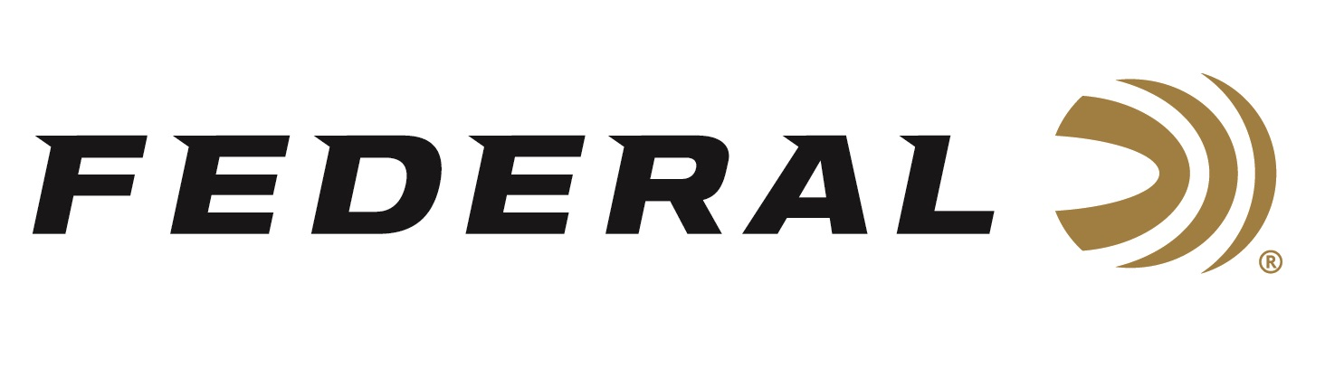
FOR IMMEDIATE RELEASE

Federal Commits to Strong Partnership with Sportsmen’s Alliance

ANOKA, Minnesota – July 2, 2024 – Federal Ammunition is proud to continue its longstanding partnership with the Sportsmen’s Alliance. The organization creates a powerful and unified voice for sportsmen and women nationwide.

“Federal Ammunition has been a constant supporter of Sportsmen’s Alliance and our mission for a very long time,” said Brian Dowler, Sportsmen’s Alliance VP of membership. “They’ve stepped up big with product for our events, but most importantly, they’re a titan in the ammunition industry. The voice of advocacy they bring for sportsmen is huge, and we’re proud they choose to support the work our team does every day to protect hunters, anglers, and trappers.”

The organization’s mission is to protect and advance America’s heritage of hunting, fishing, and trapping by uniting sportsmen to safeguard against legal and legislative attacks by the animal-rights movement, win public support for outdoor sports, ensure the future of this heritage by involving families in the outdoor experience, and promote the sportsmen’s stewardship role in the scientific management of America’s fish and wildlife.

“Our partnership with Sportsmen’s Alliance helps to continue to watch over our rights to hunt and shoot,” said Federal Ammunition’s Director of Community Relations Jon Zinnel. “They protect and defend America’s wildlife conservation programs and the pursuits that fund them. Sportsmen’s Alliance is responsible for research, public education, and legal defense. It is essential to our industry to support all the activities that our customers love.”

Members of the Sportsmen's Alliance play a vital role in protecting and promoting our outdoor heritage. Join today to create a powerful and unified voice for the hunting and shooting sports industry. Learn more at sportsmensalliance.org.

Federal ammunition can be found at dealers nationwide. For more information on all products from Federal or to shop online, visit www.federalpremium.com.

Press Release Contact: JJ Reich
Senior Manager – Press Relations
E-mail: Ammunition@tkghunt.com
About Federal Ammunition
Federal, headquartered in Anoka, MN, is an ammunition brand of The Kinetic Group. From humble beginnings nestled among the lakes and woods of Minnesota, Federal Ammunition has evolved into one of the world's largest producers of sporting ammunition. Beginning in 1922, founding President Charles L. Horn paved the way for our success. Today, Federal carries on Horn's vision for quality products and services with the next generation of outdoorsmen and women. We maintain our position as experts in the science of ammunition production. Every day, we manufacture products to enhance our customers' shooting experience while partnering with the conservation organizations that protect and support our outdoor heritage. We offer thousands of options in our Federal Premium and Federal® lines, which makes us the most complete ammunition company in the business and provides our customers with a choice no matter their pursuit.

