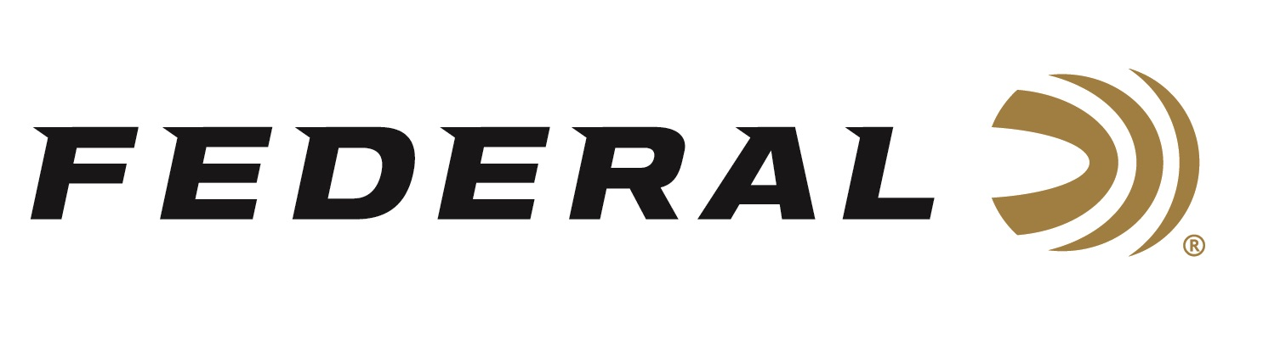
FOR IMMEDIATE RELEASE

Federal Wins Tactical Retailer’s 2023 Gold Award for Best Shotshells

ANOKA, Minnesota – April 9, 2024 – Federal has received the 2023 Gold Award in the category of Shotshells by the readers of Tactical Retailer. Shooters who read this magazine are extremely loyal to the products they use. These annual awards allow them to reveal what products they think are the absolute best.

“Federal has proven their Shotshells have phenomenal power and performance in the field as well as personal defense. This ammunition is deserving of winning the Readers' Choice Gold Award,” said Tactical Retailer Publisher Derrick Nawrocki. “Our readers can be extremely picky on the gear they choose to use, but more importantly they are very loyal to the brands they love.”

“Federal has long been a fan favorite and continues to be the consistent brand shooters trust repeatedly. We listen to our customers about what they need. Because of that, we are their top choice,” said Federal Shotshell Product Director Dan Compton. “Our new Federal Premium Personal Defense 20-gauge, 2B buckshot loads feature the rear-braking FLITECONTROL wad. This wad helps provide superior patterns, and their specialized payloads produce penetration fine-tuned to the needs of self-defense situations.”

Tactical Retailer polled its readership to find out their favorite gear; the products that really work. They then tallied the votes to determine the 2023 Readers' Choice Awards. The awards represent the best insider knowledge on products proven to work best for shooters nationwide. Reporting this knowledge helps their readers become better shooters and helps them spend their money wisely.

Federal ammunition can be found at dealers nationwide and online. For more information on all products from Federal, visit www.federalpremium.com.

Press Release Contact: JJ Reich
Senior Manager – Press Relations
E-mail: Ammunition@tkghunt.com

About Federal Ammunition
Federal, headquartered in Anoka, MN, is an ammunition brand of The Kinetic Group. From humble beginnings nestled among the lakes and woods of Minnesota, Federal Ammunition has evolved into one of the world's largest producers of sporting ammunition. Beginning in 1922, founding president, Charles L. Horn, paved the way for our success. Today, Federal carries on Horn's vision for quality products and service with the next generation of outdoorsmen and women. We maintain our position as experts in the science of ammunition production. Every day we manufacture products to enhance our customers' shooting experience while partnering with the conservation organizations that protect and support our outdoor heritage. We offer thousands of options in our Federal Premium and Federal® lines-it's what makes us the most complete ammunition company in the business and provides our customers with a choice no matter their pursuit.

