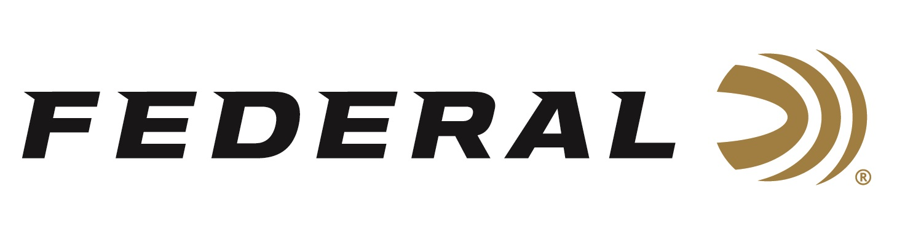
FOR IMMEDIATE RELEASE

Federal Ammunition Awards 2024 Tom Knapp Memorial Scholarships

ANOKA, Minnesota – June 27, 2024 – Federal Ammunition recently awarded the 2024 Tom Knapp Memorial Scholarships to two 4-H shooting sports teen ambassadors: Jessica Laffey from Colorado and Kaeli-Gracyn Bourgoyne from Louisiana. The scholarships were presented to the recipients at the National 4H Shooting Sports Invitational held in Grand Island, Nebraska, June 24-28. Jon Zinnel, Director of Community Relations for Federal Ammunition, announced the winners during the opening ceremonies.

In addition to the scholarships, Federal continues as the longest-tenured sponsor for the 4H Shooting Sports Program and welcomed over 700 athletes from over 40 states to the event. The organization introduces hundreds of thousands of new shooting sports enthusiasts to a wide array of shooting disciplines each year through safe and controlled programs led by certified instructors nationally.

“Both Jessica and Kaeli-Gracyn demonstrated an impressive understanding of how wildlife is managed, plus how hunting and shooting sports programs play a vital role in operating and funding the North American Model of Wildlife Conservation in our country,” said Jon Zinnel. “As a former National 4H Shooting Sports Ambassador, reviewing these applications is a highlight of my year. All these Ambassadors are tremendous citizens, which made the decision challenging. These young people had great applications and deserved the scholarship awards.”

The Tom Knapp Memorial Scholarship program, an annual initiative, was established to honor the memory of the legendary exhibition shooter Tom Knapp. Before his passing in April 2013, Knapp left an indelible mark on the shooting sports community. In 2016, Federal Ammunition and Champion Traps & Targets, in collaboration with the National 4-H Shooting Sports Committee, took up the mantle to continue this esteemed scholarship program.

Knapp, a passionate advocate for nurturing the next generation, was a respected Champion and Federal Ammunition ambassador. With the support of Knapp’s wife, Colleen, Champion extended Tom’s licensed products program to fund an endowed scholarship that annually awards $2,500 to two National 4-H Ambassadors.

Federal ammunition can be found at dealers nationwide. For more information on all products from Federal or to shop online, visit www.federalpremium.com.
Pictured: John Zinnel and Kaeli-Gracyn Bourgoyne.

Press Release Contact: JJ Reich
Senior Manager – Press Relations
E-mail: Ammunition@tkghunt.com

About Federal Ammunition
Federal, headquartered in Anoka, MN, is an ammunition brand of The Kinetic Group. From humble beginnings nestled among the lakes and woods of Minnesota, Federal Ammunition has evolved into one of the world's largest producers of sporting ammunition. Beginning in 1922, founding President Charles L. Horn paved the way for our success. Today, Federal carries on Horn's vision for quality products and services with the next generation of outdoorsmen and women. We maintain our position as experts in the science of ammunition production. Every day, we manufacture products to enhance our customers' shooting experience while partnering with the conservation organizations that protect and support our outdoor heritage. We offer thousands of options in our Federal Premium and Federal® lines, which makes us the most complete ammunition company in the business and provides our customers with a choice no matter their pursuit.

