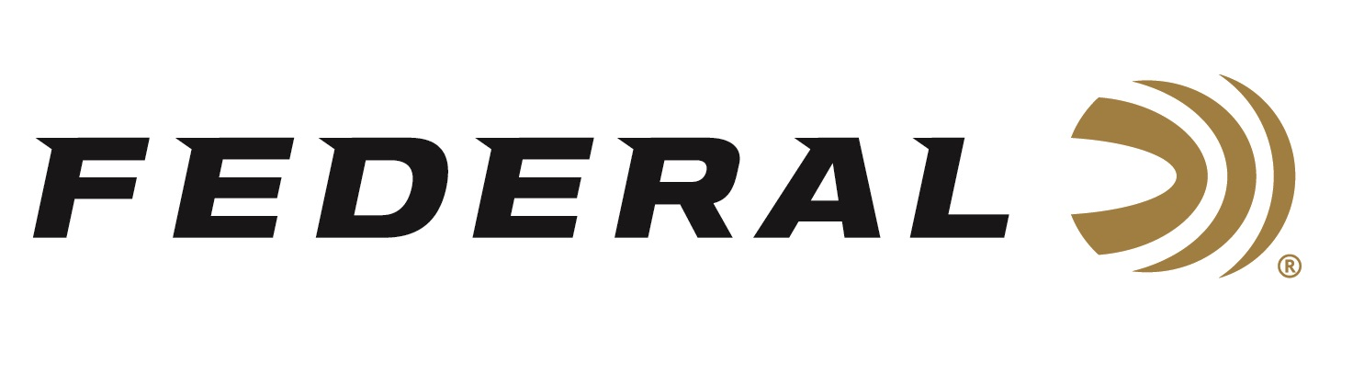
FOR IMMEDIATE RELEASE

Federal’s New Line of Top Gun Range Bags, Shell Pouches, and Gun Cases Now Available

ANOKA, Minnesota – June 25, 2024 – Federal Ammunition recently added a Top Gun accessory lineup made for those looking for solid, dependable gear at a competitive price. The product line includes a variety of shotgun cases, scoped rifle cases, shell bags, and range bags—all with durable construction and an embroidered logo. This new product line of accessories is now available at select dealers and online.

“Federal’s new accessories include three full lines of gun cases, shell pouches, and range bags. These new lineups of accessories are built for convenience, protection, and accessibility, " said Federal’s Accessories Product Manager Jake Jacobs. “We offer three new product lines to fulfill the needs of any shooter or hunter, which are Premium, Field & Range, and Top Gun. Of these, our Top Gun accessories aim to meet specific price points, and we have several styles available in this product category.”

Features and benefits of Federal’s new line of Top Gun gear include: rugged, long-lasting fabric; and web-bound edges and handles that provide durability. Bags and pouches feature a padded back panel that provides structure and comfort. Firearm cases feature protective foam padding, single-pull zippers, large hanging loops, and durable fabric lining that lets the gun slide in easily.

The product line includes six pieces: a Single Box Pouch, a Combo Shell Hull Bag, a Range Bag, a 52-inch Shotgun Case, a 40-inch Scoped Rifle Case, and a 48-inch Scoped Rifle Case. All are decorated in a tactical black color and have an MSRP ranging from $11.99 to $34.99, depending on the item.

Additionally, the Federal Neoprene Gun Sleeve delivers excellent, discreet protection to keep long guns safe from the elements. Its 53-inch length fits most long guns, and the rugged ripstop stretch neoprene keeps them safe in any condition. It also features: a drawcord closure; reinforced muzzle end; and it rolls for easy, compact storage. MSRP is $34.99.

To learn more and to see a video where Federal ambassador and professional shooter Josh Froelich walks through every item in the all-new lineups of Federal gun cases and bags, visit Gun Cases & Bags.

Federal ammunition can be found at dealers nationwide. For more information on all products from Federal or to shop online, visit www.federalpremium.com.

Press Release Contact: JJ Reich
Senior Manager – Press Relations
E-mail: Ammunition@tkghunt.com

About Federal Ammunition
Federal, headquartered in Anoka, MN, is an ammunition brand of The Kinetic Group. From humble beginnings nestled among the lakes and woods of Minnesota, Federal Ammunition has evolved into one of the world's largest producers of sporting ammunition. Beginning in 1922, founding President Charles L. Horn paved the way for our success. Today, Federal carries on Horn's vision for quality products and services with the next generation of outdoorsmen and women. We maintain our position as experts in the science of ammunition production. Every day, we manufacture products to enhance our customers' shooting experience while partnering with the conservation organizations that protect and support our outdoor heritage. We offer thousands of options in our Federal Premium and Federal® lines, which makes us the most complete ammunition company in the business and provides our customers with a choice no matter their pursuit.

