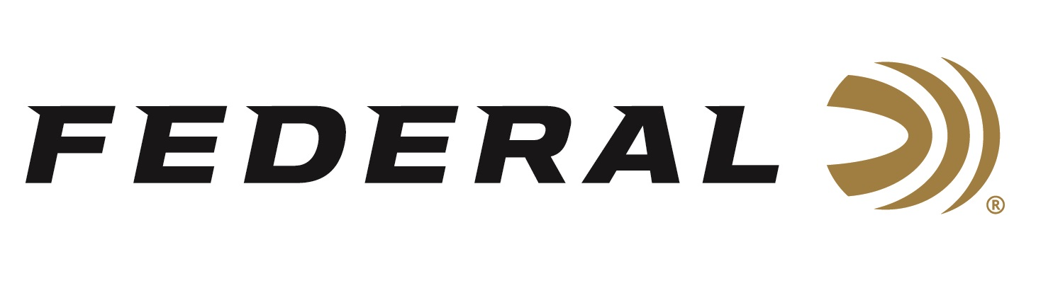
FOR IMMEDIATE RELEASE

New Federal Premium Ultra Steel Waterfowl Loads Now Available

ANOKA, Minnesota – August 2, 2024 – Federal Ammunition launches Ultra Steel, a new Premium® product line designed for waterfowlers. Product details and availability can be found on the brand website.

Ultra Steel (federalpremium.com)

“Waterfowlers live for those moments when the birds do it right. And in those moments, they want a shell that does the rest,” said Federal Shotshell Product Manager Josh Vickers. “Our new Federal Premium Ultra Steel will exceed expectations. It blends the rear-opening FLITECONTROL FLEX wad with a payload of our best zinc-plated steel, producing extremely tight patterns for even deadlier performance.”

Federal Premium Ultra Steel loads are available in various standard payloads and double-stack loads that feature two sizes of shot: smaller pellets that create full patterns and larger ones that deliver better lethality. They feature reliable primers and clean-burning propellant with 12—or 20-gauge options. They are packaged in 25-count boxes.

“Our spherical, zinc-plated steel shot creates denser core patterns; the results in the core 15-inch circle are quite impressive,” continued Vickers. The new double stack payloads make it great for multispecies hunts, such as using BB & 2 blends on field hunts when either honkers or mallards could be coming in at any time.”

Part No. / Description / MSRP
PWUX142 BB / 12GA 3” 1 1/4OZ BB 1450 FPS ULTRA STEEL / $42.99
PWUX142 2BB / 12GA 3” 1 1/4OZ BB & 2 1450 FPS ULTRA STEEL / $42.99
PWUX142 2 / 12GA 3” 1 1/4OZ 2 1450 FPS ULTRA STEEL / $42.99
PWUX142 24 / 12GA 3” 1 1/4OZ 2 & 4 1450 FPS ULTRA STEEL / $42.99
PWUX142 35 / 12GA 3” 1 1/4OZ 3 & 5 1450 FPS ULTRA STEEL / $42.99
PWUX209 2 / 20GA 3" 1OZ 1400FPS 2 ULTRA STEEL / $38.99
PWUX209 24 / 20GA 3" 1OZ 1400FPS 2 & 4 ULTRA STEEL / $38.99
PWUX209 35 / 20GA 3" 1OZ 1400FPS 3 & 5 ULTRA STEEL / $38.99

Federal ammunition can be found at dealers nationwide. For more information on all products from Federal or to shop online, visit www.federalpremium.com.

Press Release Contact: JJ Reich
Senior Manager – Press Relations
E-mail: Ammunition@tkghunt.com

About Federal Ammunition
Federal, headquartered in Anoka, MN, is an ammunition brand of The Kinetic Group. From humble beginnings nestled among the lakes and woods of Minnesota, Federal Ammunition has evolved into one of the world's largest producers of sporting ammunition. Beginning in 1922, founding President Charles L. Horn paved the way for our success. Today, Federal carries on Horn's vision for quality products and services with the next generation of outdoorsmen and women. We maintain our position as experts in the science of ammunition production. Every day, we manufacture products to enhance our customers' shooting experience while partnering with the conservation organizations that protect and support our outdoor heritage. We offer thousands of options in our Federal Premium and Federal® lines, which makes us the most complete ammunition company in the business and provides our customers with a choice no matter their pursuit.

