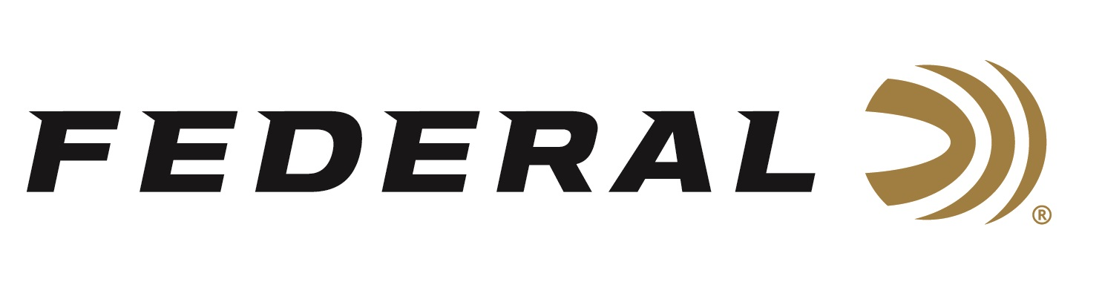

FOR IMMEDIATE RELEASE

**Federal Ammunition Continues Partnership with the Youth Shooting Sports Alliance**

**ANOKA, Minnesota – September 19, 2024 –** Federal Premium proudly announces its ongoing collaboration with the Youth Shooting Sports Alliance (YSSA), reinforcing a shared commitment to introducing safe and responsible shooting sports to new enthusiasts. As a dedicated sponsor of this exceptional organization, Federal supports YSSA's mission to foster the development of shooting sports programs that prioritize safety and responsibility.

“By supporting YSSA, our company proudly contributes to the preservation of the shooting sports heritage and shows our dedication to the next generation of hunters and target shooters,” said Federal Ammunition’s Director of Community Relations Jon Zinnel. "We firmly believe in the mission of YSSA and its efforts to introduce people to shooting sports.”

The Youth Shooting Sports Alliance was founded in 2007. The YSSA has loaned and donated equipment to youth programs nationwide, benefiting more than 120,000 youth. Visit [youthshootingsa.com](https://www.youthshootingsa.com/) to learn more.

“Federal also congratulates Kevin Kozel as its new Executive Director. He has been involved in youth shooting sports programs for over 14 years in many ways and roles,” continued Zinnel. “The organization couldn’t have found a more passionate leader to continue supporting youth development programs and take it to the next level.”

Federal ammunition is available at dealers nationwide. For more information on Federal products or to shop online, visit [www.federalpremium.com](http://www.federalpremium.com).

**Press Release Contact: JJ Reich**

Senior Manager – Press Relations

E-mail: [Ammunition@tkghunt.com](mailto:Ammunition@tkghunt.com)

**About Federal Ammunition**

Federal, headquartered in Anoka, MN, is an ammunition brand of The Kinetic Group. From humble beginnings nestled among the lakes and woods of Minnesota, Federal Ammunition has evolved into one of the world's largest producers of sporting ammunition. Beginning in 1922, founding President Charles L. Horn paved the way for our success. Today, Federal carries on Horn's vision for quality products and services with the next generation of outdoorsmen and women. We maintain our position as experts in the science of ammunition production. Every day, we manufacture products to enhance our customers' shooting experience while partnering with the conservation organizations that protect and support our outdoor heritage. We offer thousands of options in our Federal Premium and Federal® lines, which makes us the most complete ammunition company in the business and provides our customers with a choice no matter their pursuit.