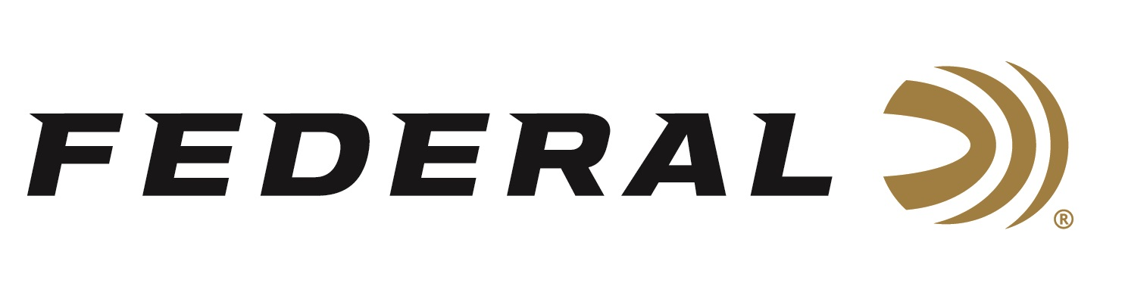
FOR IMMEDIATE RELEASE

Home On The Range: New Federal Branded Products Made By
Duluth Pack

ANOKA, Minnesota – May 20, 2024 – Federal Ammunition and Duluth Pack have teamed up to create a capsule collection of expertly handcrafted carry-all bags, hunting gear, and quality limited-edition apparel. The exclusive line of Federal products made by Duluth Pack is appropriately named “Home On The Range” which is a nod to the great homeland origins and rich histories of both Minnesota-based companies.

Federal X Duluth Pack (federalpremium.com)

“We are happy to collaborate with Duluth Pack, an iconic Minnesota brand,” said Vice President of Marketing Jason Nash. “Our two companies have a lot in common when it comes to strong work ethic, reliable products, made in America, and deep-rooted histories within the outdoor industry and our home state of Minnesota.”

The new line of merchandise ranges from the popular Rambler outdoor pack and Upland Hunting Game Vest to full-length zipped Canvas Chaps and Grab-N-Go bags. There’s also a stylish beanie available in three colors, plus limited-edition, graphic sweatshirts, and t-shirts.

“It feels so incredibly natural to collaborate with such an iconic Minnesota brand, like Federal Ammunition,” said Duluth Pack President and CEO Tom Sega. “Both of our companies have such a long history of classic, reliable, and generationally trusted products, along with corporate values that align so well.”

The Home On The Range collection will launch on Wednesday, May 15th exclusively on the Federal ecommerce site. The collection of new products will retail between $46 to $378 for the Duluth Pack handcrafted items and $23 to $55 for branded apparel.

With items added frequently—alongside exciting sales and promotions—customers are encouraged to check Federal’s Merchandise section on the company’s website regularly to see what’s new: https://www.federalpremium.com/merchandise/.

Federal ammunition can be found at dealers nationwide and online. For more information on all products from Federal, visit www.federalpremium.com.

Press Release Contact: JJ Reich
Senior Manager – Press Relations
E-mail: Ammunition@tkghunt.com

About Federal Ammunition
Federal, headquartered in Anoka, MN, is an ammunition brand of The Kinetic Group. From humble beginnings nestled among the lakes and woods of Minnesota, Federal Ammunition has evolved into one of the world's largest producers of sporting ammunition. Beginning in 1922, founding president, Charles L. Horn, paved the way for our success. Today, Federal carries on Horn's vision for quality products and service with the next generation of outdoorsmen and women. We maintain our position as experts in the science of ammunition production. Every day we manufacture products to enhance our customers' shooting experience while partnering with the conservation organizations that protect and support our outdoor heritage. We offer thousands of options in our Federal Premium and Federal® lines-it's what makes us the most complete ammunition company in the business and provides our customers with a choice no matter their pursuit.

