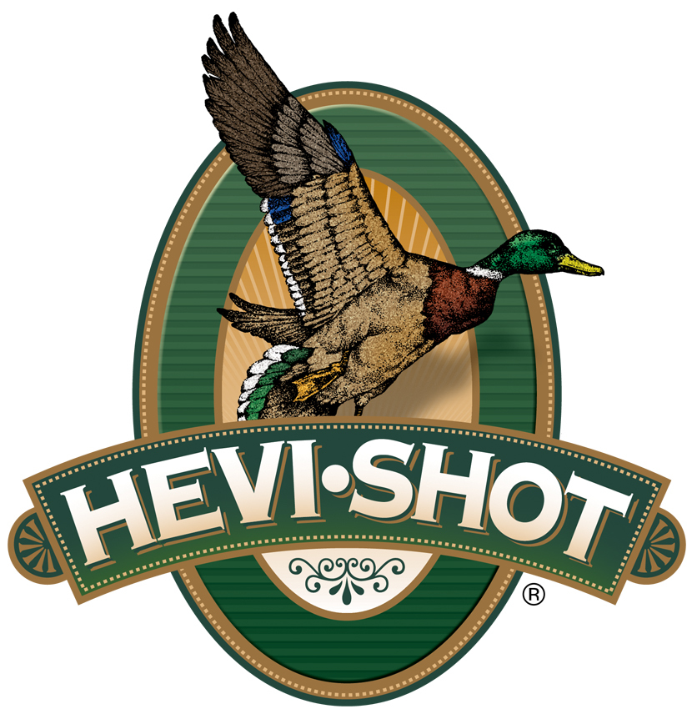

FOR IMMEDIATE RELEASE

HEVI-Shot’s New 3-Inch, 28-Gauge Turkey Loads Now Available

SWEET HOME, Oregon – March 14, 2024 – HEVI-Shot Ammunition is now manufacturing new 3-inch, 28-gauge turkey loads in their HEVI-18 TSS and Magnum Blend product lines. These two new products have been shipping to dealers in time for spring turkey hunting seasons.

“With the popularity of the new 3-inch, 28-gauge Super Black Eagle III shotgun from Benelli, it just made sense for us to produce two good options for turkey hunting,” said HEVI-Shot product manager Scott Turner. “And, with other gun companies, such as Mossberg, also offering 3-inch, 28-gauge shotguns, we predict the 28-gauge will be the hot new trend for wild turkey hunters in 2024 and beyond. We are excited to now offer these 28-gauge loads, and we know wild turkey hunters will be happy that we did.”

HEVI-18 Tungsten Super Shot (TSS) Turkey uses high-density 18 g/cc pellets and friction-reducing spherical buffer to extend effective range beyond what's ever been possible. Pushed at high velocities, TSS pellets carry more energy farther downrange, allowing hunters to drop three shot sizes from common lead payloads and get higher pellet counts and denser patterns. HEVI-Shot HEVI-18 TSS Turkey’s overall product line now consists of twelve total load options, available in 12-, 20-, and 28-gauge, plus 410 bore. New 3-inch, 28-gauge loads are available in shot sizes No. 7 or 9.

HEVI-18 TSS Turkey | Hevi Shot

Magnum Blend offers three shot sizes (5, 6 and 7) in a single shell. The 12 g/cc cast tungsten lets you drop one shot size from lead for the same lethality. These heavy loads really pack some punch: 437 deadly pellets in a single 12-gauge, 3-inch shell. HEVI-Shot’s Magnum Blend Turkey product line now consists of five total load options, available in 10-, 12-, 20-, or 28-gauge. The new load now available is a 3-inch, 1-ounce, 28-gauge option.

Magnum Blend | Hevi Shot

HEVI-Shot ammunition can be found at dealers nationwide and online. For more information on all products from HEVI-Shot, visit www.hevishot.com.

Press Release Contact: JJ Reich
Senior Manager – Press Relations
E-mail: Ammunition@tkghunt.com

About HEVI-Shot
Established in 2000 and based out of Sweet Home, Oregon, HEVI-Shot is an ammunition brand of The Kinetic Group. HEVI-Shot is an industry leader in performance shotshell, providing the next generation of shotshell loads to hunters—with their large and impressive selection of hunting ammunition options. HEVI-Shot is synonymous with high performance projectiles. The company meticulously designs each product to outperform any ammunition competitor in its class. That is why HEVI-Shot is the ammunition choice for serious hunters who live by their slogan: “I DIDN’T COME THIS FAR TO MISS!”

