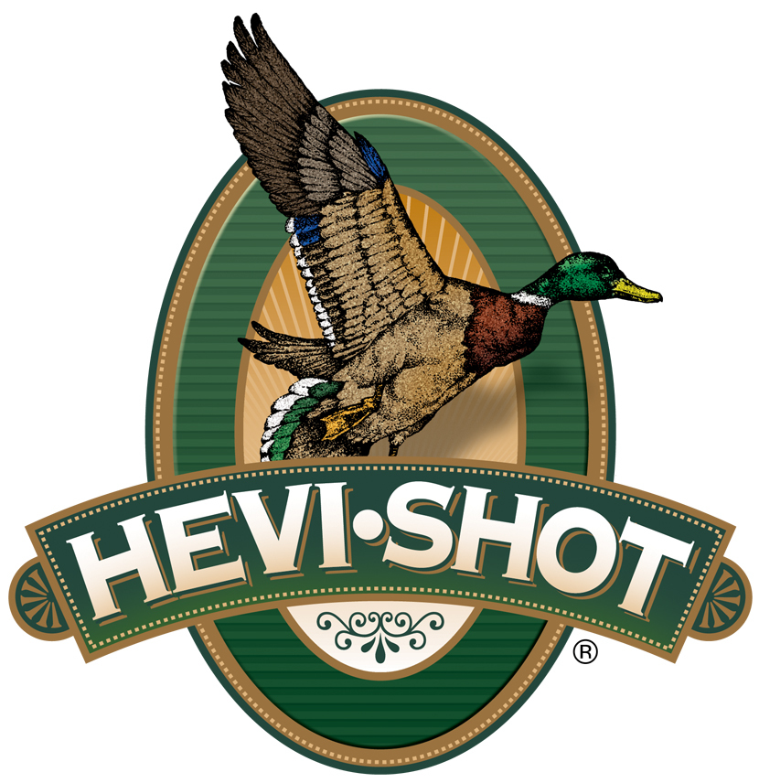

FOR IMMEDIATE RELEASE

HEVI-Shot Ammunition Releases New HEVI-Bismuth 16-Gauge Upland Loads

SWEET HOME, Oregon – January 12, 2024 – HEVI-Shot is proud to release two new line extensions in its HEVI-Bismuth Upland product lineup. Two new 16-gauge loads have recently been added to the company’s website and are now available. The new loads are Part No. HS16715; 16 Gauge, 2-3/4-inch, Shot Size 5, 1,325 fps, and Part No. HS16713; 16 Gauge, 2-3/4-inch, Shot Size 3, 1,325 fps.

New HEVI-Bismuth Upland 16 Gauge

“We are excited to add 16-gauge to our HEVI-Bismuth Upland product family. They are excellent for hunters targeting pheasants, grouse and other hard-flushing upland birds,” said HEVI-Shot product manager Scott Turner. “HEVI-Bismuth Upland payloads are 22 percent denser than steel to deliver more pellets on target and maximum knockdown power. They meet nontoxic requirements and are safe for fixed-choke barrels and modern shotguns. This thorough lineup should cover any upland hunter’s needs and preferences.”

Summary of features include: 100-percent non-toxic bismuth pellets with a high density of 9.64 g/cc; Soft shot that is safe for modern and classic shotguns; Hits hard like lead with more downrange energy for more clean kills with less wounding; Quality components with all-season reliability; Alloyed and loaded in Sweet Home, Oregon, U.S.A.; 25-round boxes; MSRP: $76.99.

HEVI-Shot is available at dealers nationwide and online. For more information on all products from HEVI-Shot, visit www.hevishot.com.

Press Release Contact: JJ Reich
Senior Manager – Press Relations
E-mail: VistaPressroom@VistaOutdoor.com

About HEVI-Shot
Established in 2000 and based out of Sweet Home, Oregon, HEVI-Shot is a brand of Vista Outdoor Inc., an outdoor sports and recreation company. HEVI-Shot is an industry leader in performance shotshell, providing the next generation of shotshell loads to hunters—with their large and impressive selection of hunting ammunition options. HEVI-Shot is synonymous with high performance projectiles. The company meticulously designs each product to outperform any ammunition competitor in its class. That is why HEVI-Shot is the ammunition choice for serious hunters who live by their slogan: “I DIDN’T COME THIS FAR TO MISS!”

