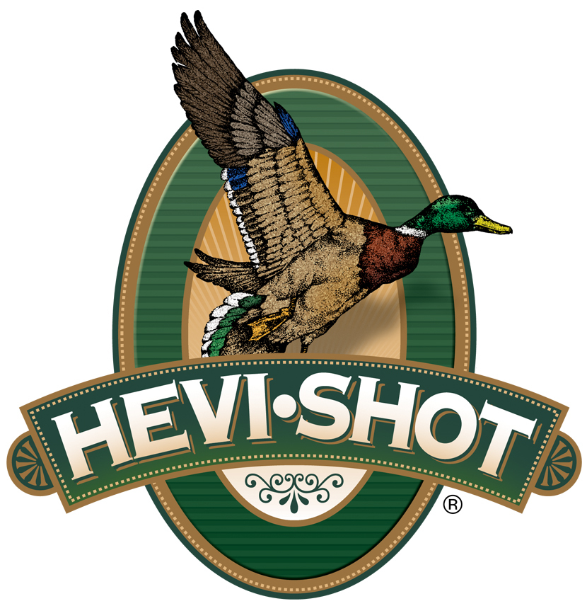

FOR IMMEDIATE RELEASE

HEVI-Shot

Ammunition Sponsors the 2024 Delta Waterfowl Expo
SWEET HOME, Oregon – July 18, 2024 – HEVI-Shot Ammunition will join the 2024 Delta Waterfowl Expo as an exhibitor and Teal Level Sponsor. The event is July 26-28 at the Raising Cane’s River Center in Baton Rouge, Louisiana. Visitors to the Expo can stop by booth No. 50 to see the latest and greatest products from HEVI-Shot.

“We are excited to be one of the exhibitors and sponsors of the 2024 Delta Waterfowl Expo. We are proud to continue helping to promote and support the mission of Delta Waterfowl and the great research and conservation work they are doing,” said Tina Larsen, HEVI-Shot’s Marketing Manager. “We look forward to meeting with all the like-minded waterfowl enthusiasts at the Expo and talking all about shotshell ammo.”

The 2024 Delta Waterfowl Expo will continue to help Delta Waterfowl in its mission to restore more waterfowl habitat through proven conservation methods. Over the three-day event, attendees can see the latest waterfowl gear, meet hunters from all over the country, participate in raffles, and learn from experts at numerous seminars. At the HEVI-Shot booth, brand ambassador and influencer Maggie Williams will greet attendees on Friday from 5-6 p.m., plus Saturday and Sunday from 12 to 2 p.m.

New loads for waterfowlers in 2024 include HEVI-XII in .410 Bore in shot sizes No. 5 & 7, and HEVI-Metal Xtreme in 12-GA in stacked shot size No. 2/BB.

Loaded with HEVI-Shot’s original 12 g/cc tungsten, which is 53.8 percent denser than steel, HEVI-XII loads double the downrange energy, hitting birds harder from a longer distance. This means you can drop three shot sizes for the same lethality and still put 28 percent more pellets on target.

HEVI-Metal Xtreme devotes 30 percent of the payload to HEVI-Shot 12 g/cc tungsten pellets (No. 2) stacked over steel shot (BB). It also features the FLITECONTROL FLEX wad for consistent long-range patterns and is pushed at high velocities.

HEVI-Shot ammunition is available at dealers nationwide and online. For more information on all products, visit www.hevishot.com.

Press Release Contact: JJ Reich
Senior Manager – Press Relations
E-mail: VistaPressroom@VistaOutdoor.com

About HEVI-Shot
Established in 2000 and based out of Sweet Home, Oregon, HEVI-Shot is an ammunition brand of The Kinetic Group. HEVI-Shot is an industry leader In performance shotshell, providing the next generation of shotshell loads to hunters—with their large and impressive selection of hunting ammunition options. HEVI-Shot is synonymous with high-performance projectiles. The company meticulously designs each product to outperform any ammunition competitor in its class. That is why HEVI-Shot is the ammunition choice for serious hunters who live by their slogan: “I DIDN’T COME THIS FAR TO MISS!”

