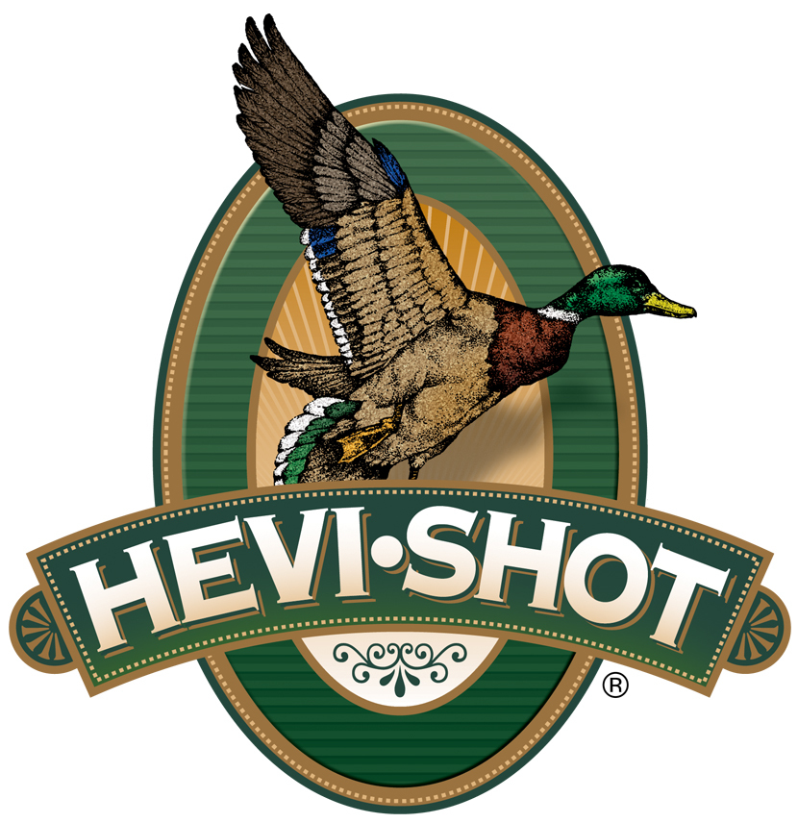

FOR IMMEDIATE RELEASE

HEVI-Shot Will Showcase New Turkey Loads and Host Brand Influencers at the 2024 NWTF Sport Show

SWEET HOME, Oregon – February 12, 2024 – HEVI-Shot will showcase new turkey and waterfowl loads, plus host several brand influencers in their booth at the National Wild Turkey Federation’s (NWTF) 48th Annual Convention and Sport Show. The big event will be held February 14-18, 2023 in Nashville, Tennessee.

“We are excited to showcase our turkey loads at this big event and particularly excited about our 3-inch, 28-gauge loads. We feel 28-gauge will soon be a big trend in turkey hunting, and we have several great options, in both our HEVI-18 TSS and Magnum Blend product families, in 28 gauge,” said Tina Larsen, HEVI-Shot’s Marketing Manager. “In addition, we will also be hosting some special guests in our booth this year. These brand influencers are excited to visit with fellow turkey hunters. It will be a great time."

HEVI-Shot’s HEVI-18 TSS features straight payloads of ultra-high density pellets, which are 18 grams per cubic centimeter (g/cc). TSS is 56 percent denser than lead and is harder than steel. It offers the ultimate in knock-down power. For hunters looking for performance at a lesser price tag, HEVI-Shot’s Magnum Blend features payloads consisting of three shot sizes (5, 6, and 7) in a single shell and has excellent terminal performance on wild turkeys. Their 12 g/cc tungsten pellets are alloyed and cast at HEVI-Shot’s factory in Sweet Home, Oregon.

Attendees of the NWTF’s 2024 Convention and Sport Show are encouraged to stop by HEVI-Shot’s booth No. 1009 to talk with HEVI-Shot’s enthusiastic staff and brand influencers. Beau Brooks will appear Thursday from 2 to 3 p.m., Tony Vandemore on Friday from 11 a.m. to 12 p.m., and Maggie Williams on Saturday from 1 to 2 p.m.

“We just recently signed Maggie Williams as a Brand Ambassador, which includes sponsorship of The Maggie Williams Podcast throughout 2024,” said Larson. “Maggie is a serious outdoorswoman, and her podcast is fun, informative, and entertaining.”

Maggie Williams is a 22-year-old outdoorswoman from Arkansas. In 2019, she was crowned Miss Arkansas Teen USA where she took that opportunity to promote female participation in hunting on a national level. In 2023, she became the host of The Maggie Williams Podcast, which quickly rose high on popularity charts and continues to be the No. 1 female-hosted outdoors podcast in the country.

HEVI-Shot ammunition can be found at dealers nationwide or online. For more information on all products from HEVI-Shot, visit www.hevishot.com.

Press Release Contact: JJ Reich
Senior Manager – Press Relations
E-mail: VistaPressroom@VistaOutdoor.com

About HEVI-Shot
Established in 2000 and based out of Sweet Home, Oregon, HEVI-Shot is a brand of Vista Outdoor Inc., an outdoor sports and recreation company. HEVI-Shot is an industry leader In performance shotshell, providing the next generation of shotshell loads to hunters—with their large and impressive selection of hunting ammunition options. HEVI-Shot is synonymous with high performance projectiles. The company meticulously designs each product to outperform any ammunition competitor in its class. That is why HEVI-Shot is the ammunition choice for serious hunters who live by their slogan: “I DIDN’T COME THIS FAR TO MISS!”

