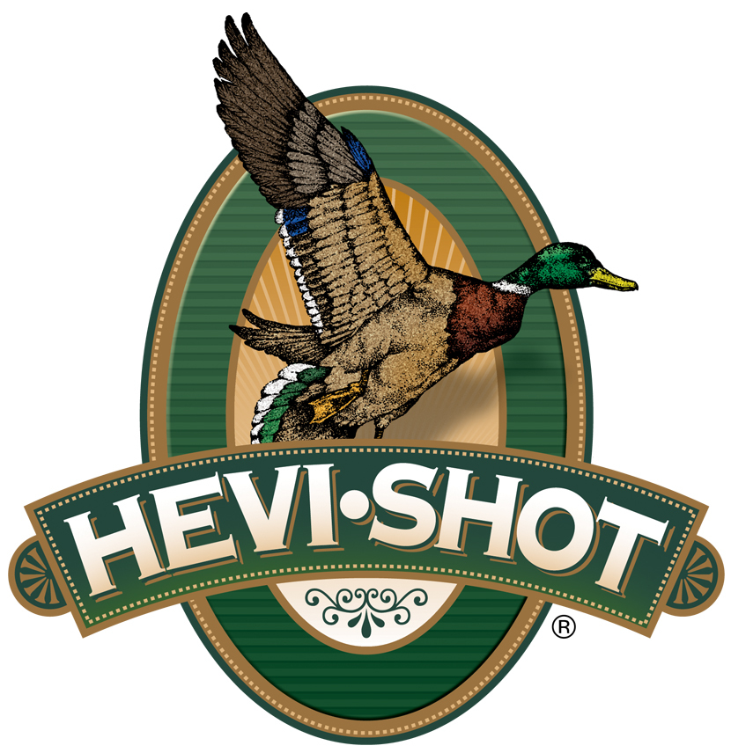

FOR IMMEDIATE RELEASE

New HEVI-Shot HEVI-Steel Layered Waterfowl Loads Now Available

SWEET HOME, Oregon – October 22, 2024 – HEVI-Shot adds new product options in its HEVI-Steel Waterfowl lineup. The four new layered steel pellet loads, in 12- or 20-gauge, feature two different-sized precision steel pellets layered in the same shell, dependable ignition, and a unique HEVI-Shot wad to produce tight and reliable patterns. This new product line is now available at select dealers and online. Check with your local ammo store for availability.

“We make layered loads to maximize pattern density and increase down-range energy,” said Scott Turner, HEVI-Shot Shotshell Product Line Manager. “By layering two different shot sizes, we can tailor steel pellet shotshells to deliver a good balance of power—with the inclusion of the larger shot size—and performance—with the smaller shot size—at a specific price point.”

Features of HEVI-Shot's HEVI-Steel layered shotshells include: 7.8 g/cc precision steel pellets; Clean-burning propellant; Best-in-class wad; Dependable ignition; High velocity provides more downrange energy for waterfowl hunting; Two layered shot sizes in BB and 2, or 2 and 4 for 12-gauge and 2 and 4, or 3 and 5 for 20-gauge.

Technical Specifications:

Gauge: 12 Gauge
Shot Size: BB and 2, or 2 and 4
Shotshell Length: 3 inch / 76 mm
Muzzle Velocity: 1,450 fps
Type: Steel
Shot Charge: 1 3/8 Ounce
Density: 7.8 g/cc
Package Quantity: 25
Usage: Waterfowl
MSRP: $30.99

Gauge: 20 Gauge
Shot Size: 2 and 4, or 3 and 5
Shotshell Length: 3 in / 76 mm
Muzzle Velocity: 1,350 fps
Type: Steel
Shot Charge: 1 Ounce
Density: 7.8 g/cc
Package Quantity: 25
Usage: Waterfowl
MSRP: $27.99
HEVI-Shot ammunition can be found at dealers nationwide or online. For more information on all products from HEVI-Shot, visit www.hevishot.com.

Press Release Contact: JJ Reich
Senior Manager – Press Relations
E-mail: Ammunition@tkghunt.com

About HEVI-Shot
Established in 2000 and based out of Sweet Home, Oregon, HEVI-Shot is an ammunition brand of The Kinetic Group. HEVI-Shot is an industry leader In performance shotshell, providing the next generation of shotshell loads to hunters—with their large and impressive selection of hunting ammunition options. HEVI-Shot is synonymous with high-performance projectiles. The company meticulously designs each product to outperform any ammunition competitor in its class. That is why HEVI-Shot is the ammunition choice for serious hunters who live by their slogan: “I DIDN’T COME THIS FAR TO MISS!”

