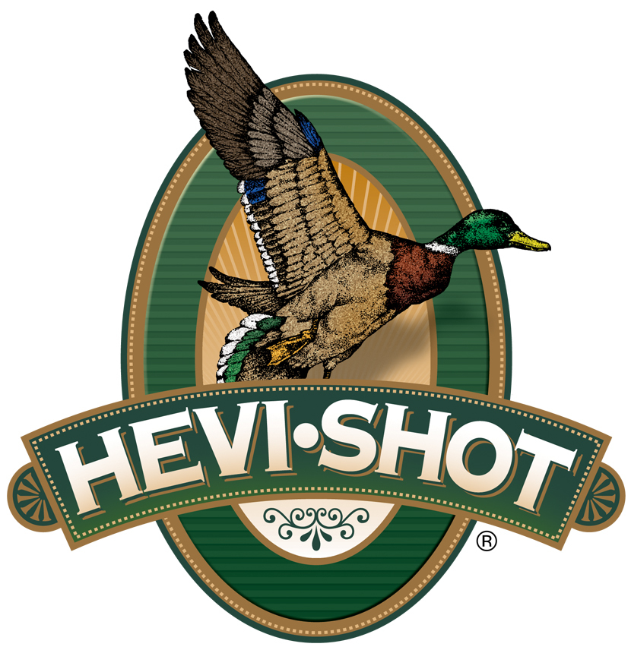

FOR IMMEDIATE RELEASE

New HEVI-Shot HEVI-Steel Upland Loads Now Available

SWEET HOME, Oregon – July 8, 2024 – HEVI-Shot launches a new product line called HEVI-Steel Upland. The two new high-velocity, 12-gauge dove and quail loads feature precision steel pellets, dependable ignition, and a unique HEVI-Shot wad to produce exceptionally tight patterns. This new product line is now available at select dealers and online. Check with your local ammo store for availability.

“When a dove races across a field or a covey of quail erupts at your feet, speed matters. That’s why we push HEVI-Steel Upland faster than competing steel loads,” said Dan Compton, HEVI-Shot’s Shotshell Product Director. “The velocity boost we gave these loads makes it easier to connect on hard-flying birds and delivers more energy on impact. They are perfect for upland hunters looking for a good, non-toxic, steel-shot option at a competitive price point.”

Aided by HEVI-Shot’s best-in-class wad and precision manufacturing techniques, HEVI-Steel Upland hits hard every time. Its high velocity of 1,350 feet per second (fps) provides ideal downrange energy. The two new 12-gauge, 2-3/4-inch loads will be available in shot size No. 6 or 7 and sold in a 25-count box.

Technical Specifications:
Gauge: 12
Shot Size: No. 6 or No. 7
Shot Type: 7.8 g/cc precision steel
Muzzle Velocity: 1,350 fps
Shotshell Length: 2-3/4-inch / 70mm
Shot Charge: 1-ounce
Package Quantity: 25
Usage: Small Upland Birds

Part No. / Description / MSRP
HS61227 / HEVI-Steel Upland 12g, 2 3/4”, 7, 1oz, 25/box / $19.99
HS61266 / HEVI-Steel Upland 12g, 2 3/4”, 6, 1oz, 25/box / $19.99

HEVI-Shot ammunition can be found at dealers nationwide or online. For more information on all products from HEVI-Shot, visit www.hevishot.com.
Press Release Contact: JJ Reich
Senior Manager – Press Relations
E-mail: VistaPressroom@VistaOutdoor.com

About HEVI-Shot
Established in 2000 and based out of Sweet Home, Oregon, HEVI-Shot is an ammunition brand of The Kinetic Group. HEVI-Shot is an industry leader In performance shotshell, providing the next generation of shotshell loads to hunters—with their large and impressive selection of hunting ammunition options. HEVI-Shot is synonymous with high-performance projectiles. The company meticulously designs each product to outperform any ammunition competitor in its class. That is why HEVI-Shot is the ammunition choice for serious hunters who live by their slogan: “I DIDN’T COME THIS FAR TO MISS!”

