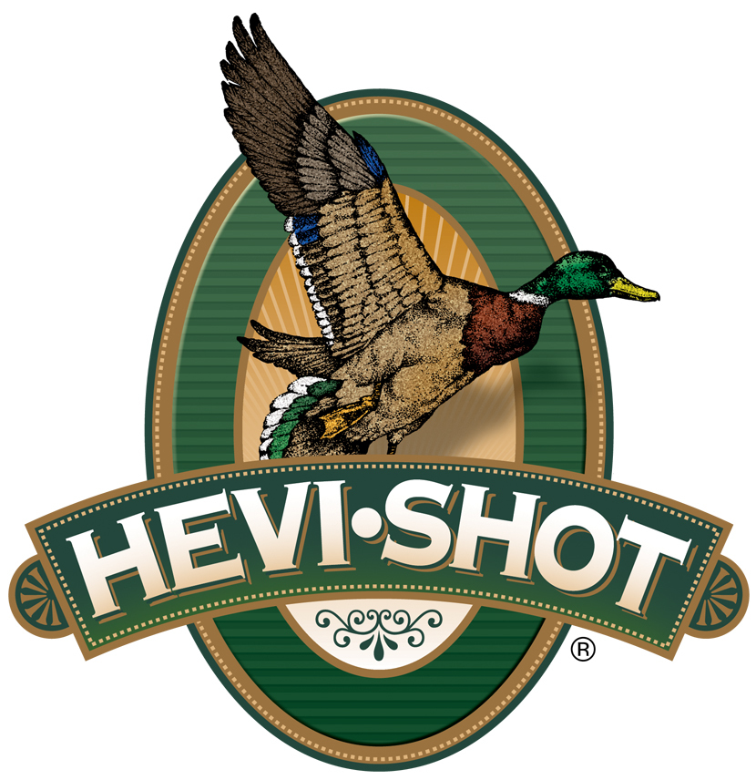

FOR IMMEDIATE RELEASE

New HEVI-Shot HEVI-XII 410 Bore Shotshells Now Available

SWEET HOME, Oregon – August 12, 2024 – HEVI-Shot expands its HEVI-XII tungsten load lineup with the addition of two new 410 bore loads in 3-inch, No. 5, and No. 7. This new product line is now available at select dealers and online. Product details and availability can be found on the brand's website.

HEVI-XII

“For those looking to target waterfowl, upland birds, and small game with the 410-bore, they can now shoot HEVI-Shot’s original 12 g/cc tungsten pellets,” said Dan Compton, HEVI-Shot’s Shotshell Product Director. “These two new loads are set to a high velocity, with high pellet counts, delivering more lethal pellets in a tighter pattern. They outperform 410-bore steel and lead loads in every category.”

Loaded with HEVI-Shot’s original 12 g/cc tungsten, which is 53.8 percent denser than steel, these loads double the downrange energy, hitting birds harder from a longer distance. This means hunters can drop three shot sizes for the same lethality and still put 28 percent more pellets on target.

Technical Specifications:
Gauge: 410 Bore
Shot Size: No. 5 or No. 7
Shotshell Length: 3-inch / 76mm
Muzzle Velocity: 1250
Shot Charge Oz: 0.5
Type: Tungsten
Package Quantity: 25
Usage: Waterfowl

Part No. / Description / MSRP
HS54105 / HEVI-XII .410, 3”, 5, 1/2 oz, 25/box / $104.99
HS54107 / HEVI-XII .410, 3”, 7, 1/2 oz, 25/box / $104.99

HEVI-Shot ammunition can be found at dealers nationwide or online. For more information on all products from HEVI-Shot, visit www.hevishot.com.

Press Release Contact: JJ Reich
Senior Manager – Press Relations
E-mail: Ammunition@tkghunt.com

About HEVI-Shot
Established in 2000 and based out of Sweet Home, Oregon, HEVI-Shot is an ammunition brand of The Kinetic Group. HEVI-Shot is an industry leader In performance shotshell, providing the next generation of shotshell loads to hunters—with their large and impressive selection of hunting ammunition options. HEVI-Shot is synonymous with high-performance projectiles. The company meticulously designs each product to outperform any ammunition competitor in its class. That is why HEVI-Shot is the ammunition choice for serious hunters who live by their slogan: “I DIDN’T COME THIS FAR TO MISS!”

