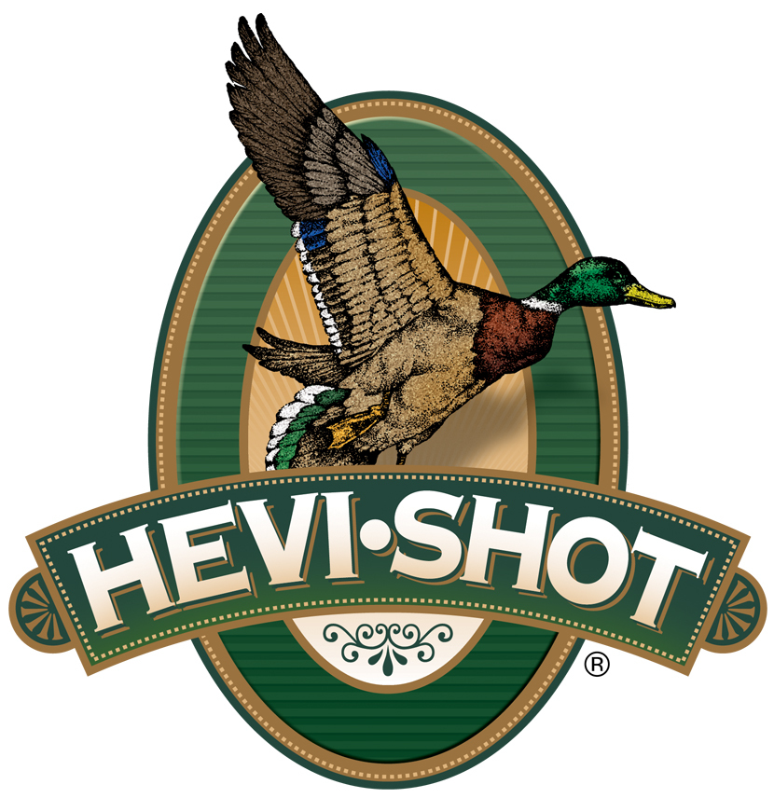

FOR IMMEDIATE RELEASE

HEVI-Shot Ammunition Announces Several New Loads for 2024

SWEET HOME, Oregon – January 11, 2024 – HEVI-Shot is proud to announce several new waterfowl loads for 2024: An all-new, steel-shot product line and two new tungsten-shot line extensions will be showcased and on display at the 2024 SHOT Show (Booth No. 11838), January 23–26 at the Venetian Expo and Caesars Forum in Las Vegas, Nevada.

The all-new, steel-shot product line—targeted for upland hunters—is aptly named HEVI-Steel Upland. These 12-gauge upland-focused loads feature 7.8 g/cc precision steel pellets, in size No. 6 or 7, dependable ignition, and a unique HEVI-Shot wad to produce exceptionally tight patterns. Their high velocity provides more downrange energy.

The first new line extension is HEVI-Metal Xtreme 12 Gauge in shot size No. 2/BB. HEVI-Metal Xtreme uses Pattern Density Technology to devote 30 percent of the payload to HEVI-Shot 12 g/cc tungsten pellets (size No. 2) and stack them over steel shot (size BB). The dense tungsten pellets are three shot sizes smaller than the steel to ensure both layers have equal downrange performance. The load features the FLITECONTROL FLEX wad for consistent long-range patterns and is pushed at high velocities.

The second new line extension is HEVI-XII 410 Bore in shot sizes No. 5 and 7. Loaded with HEVI-Shot’s original 12 g/cc tungsten that’s 53.8 percent denser than steel, these loads double the downrange energy, hitting birds harder from a longer distance. This means you can drop three shot sizes for the same lethality and still put 28 percent more pellets on target.

Attendees of the 2024 SHOT Show are encouraged to stop by Booth No. 11838 for a first-hand look at these new products and more. For more information on all products from HEVI-Shot, visit www.hevishot.com.

Press Release Contact: JJ Reich
Senior Manager – Press Relations
E-mail: VistaPressroom@VistaOutdoor.com
About HEVI-Shot
Established in 2000 and based out of Sweet Home, Oregon, HEVI-Shot is a brand of Vista Outdoor Inc., an outdoor sports and recreation company. HEVI-Shot is an industry leader in performance shotshell, providing the next generation of shotshell loads to hunters—with their large and impressive selection of hunting ammunition options. HEVI-Shot is synonymous with high performance projectiles. The company meticulously designs each product to outperform any ammunition competitor in its class. That is why HEVI-Shot is the ammunition choice for serious hunters who live by their slogan: “I DIDN’T COME THIS FAR TO MISS!”

