FOR IMMEDIATE RELEASE

Remington Announces 3rd Annual Shoot to Cure Fundraiser

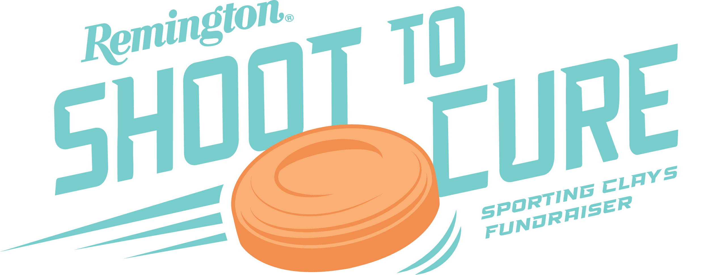

LONOKE, Ark. – July 11, 2024 – Remington Ammunition will be hosting its 3rd Annual Shoot to Cure sporting clays fundraiser on September 20, 2024. This exciting event brings together the outdoor industry, local Arkansas businesses and professional shooters from Team Remington to support the Arkansas Children's Foundation as well as children’s hospitals and disease research nationwide.

Showcasing Remington’s Gun Club Cure line of target shotshell ammunition, last year’s event was an overwhelming success, with participants and sponsors raising over $15,000.

“Big Green is delighted to announce another year of the Shoot to Cure event,” said Remington’s Director of Marketing Joel Hodgdon. “We are passionate about making a difference in the lives of children in our local community and beyond. We hope to see plenty of shooters of all skill levels join us again at this year’s event for a chance to win great prizes, bragging rights and ultimately raise even more support for a great cause.”

Remington receives support from sponsors around the industry and would like to thank the sponsors of the 2023 event including Nighthawk Custom, Starline Brass, Benelli, Hornady, Fort Thompson Sporting Goods and Rob Roberts Custom Gun Works.

Hosted at Remington’s historic Gun Club just steps from Big Green’s ammunition factory, the club features facilities for trap, skeet, sporting clays and five-stand. Whether it's a family outing, corporate event or a ​sanctioned ​competition, Remington Gun Club allows visitors to put the world's finest shotshells to the ultimate test.

Those interested in participating or sponsoring Shoot to Cure can email kris.carson@remington.com

Press Release Contact: Jackson Crawford and Jonathan Harling
Remington Public Relations
E-mail: remingtonammopr@murrayroadagency.com

About Remington
From muskets to modern day, generations of hunters and shooters have trusted Remington ammunition and accessories. Loaded in Lonoke, Arkansas by American workers, our wide array of pioneering sporting and hunting ammunition promises to get the job done every time the trigger is pulled. At Remington, we’re here for everyone who loads a round of ammo into a handgun, rifle, or shotgun.

Founded in 1816, Remington and America have fought and won wars, put food on millions of tables and brought countless generations together at the range and in the field. We are proud of each and every round that rolls off our factory line. An ammunition brand of the Kinetic Group, Remington is bringing a renewed focus to ammunition, innovation, and quality – all while staying true to Remington’s legendary heritage and stature as an American icon.

