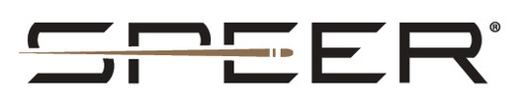

FOR IMMEDIATE RELEASE

United States Special Operations Chooses Speer Gold Dot G2

LEWISTON, Idaho – February 15, 2024 – The United States Special Operations Command (USSOCOM) has awarded Speer Ammunition with a three-year contract that continues supplying SOCOM with Speer Gold Dot G2 duty ammunition. The contract has a maximum of 8.5 million rounds.

“When it comes to dependability and terminal ballistics, Speer is the gold standard. That’s why Speer is a top choice of law enforcement and military professionals,” said Vice President of Government Sales David Leis. “Speer continues to supply our U.S. DOD and unified forces with superior products for their efforts in protecting U.S. global interests.”

Speer Gold Dot G2 offers the ultimate performance in duty ammunition, thanks to an exclusive nose design. Instead of a large hollow-point cavity, Gold Dot G2 has a shallow dish filled with a high-performance elastomer. On impact, the material is forced into engineered internal fissures to start the expansion process. The result is extremely uniform expansion, better separation of the petals, and more consistent penetration across barrier types through duty handguns.

Speer Ammunition can be found at dealers nationwide and online. For more information on all products from Speer, visit www.speer.com.

Press Release Contact: JJ Reich
Senior Manager – Press Relations
E-mail: VistaPressroom@VistaOutdoor.com

About Speer
Headquartered in Lewiston, Idaho, the brand has a long-standing reputation for making the world's finest bullets and in 1996 became one of the first U.S. ammunition manufacturers to achieve ISO 9001 certification for quality. The company manufactures a variety of bullets and cartridges for law enforcement, reloading and sporting applications. Speer is part of Vista Outdoor Inc., an outdoor sports and recreation corporation.

