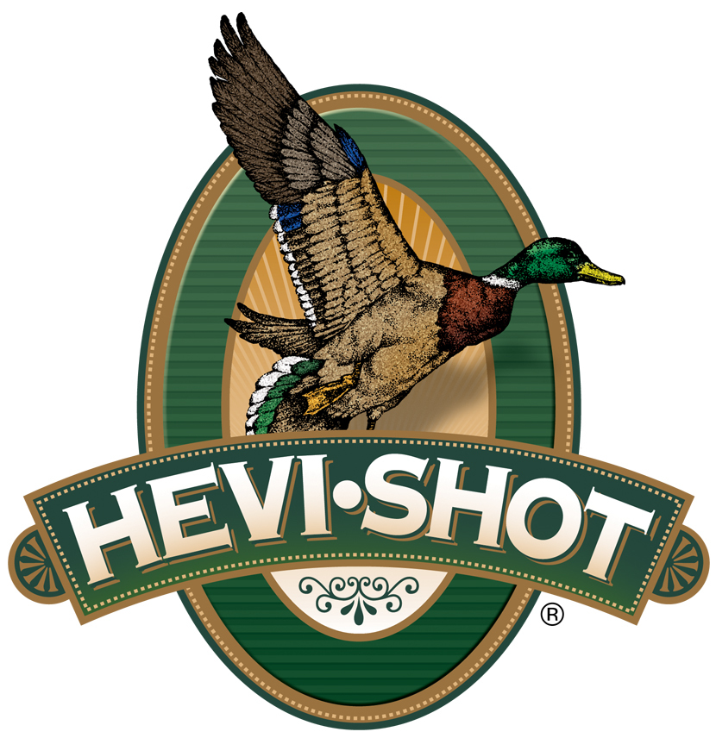

FOR IMMEDIATE RELEASE

New HEVI-Hitter Waterfowl Loads Now Shipping Nationwide

SWEET HOME, Oregon – June 11, 2025 – HEVI-Shot’s all-new shotshell product line, HEVI-Hitter, is a lineup of waterfowl loads designed to deliver a balance of the sheer power of tungsten with the patterning and practicality of steel to deliver better lethality on ducks and geese. HEVI-Hitter will be initially available in eleven options: 12-, 16-,
20-, and 28-gauge. These new shotshells are now shipping to retailers nationwide.

HEVI-Hitter

“Our HEVI-Hitter devotes 20 percent of its payload to 12 g/cc tungsten and layers it over 80 percent steel shot,” said HEVI-Shot’s Product Line Manager Scott Turner. “In general, due to both types of pellets being the same shot size, the tungsten layer hits 54 percent harder in terms of kinetic energy and momentum, delivering exceptional impact performance. This carefully engineered blend brings out the best in both materials, delivering what is needed to drop birds at various ranges.”

Features and benefits include 20 percent 12 g/cc tungsten and 80 percent precision steel payload, large patterns at close to moderate range, pellet counts and power for longer-range kills, reliable HEVI-Shot wad and primer, and nontoxic shot for use in restricted hunting areas.

Part No. / Description / MSRP
HS28288 / HEVI-Hitter 12-ga, 3-in, 1 1/4-oz, BB Tungsten/Steel, 1,500 fps / $49.99
HS28022 / HEVI-Hitter 12-ga, 3-in, 1 1/4-oz, No. 2 Tungsten/Steel, 1,500 fps / $49.99
HS28033 / HEVI-Hitter 12-ga, 3-in, 1 1/4-oz, No. 3 Tungsten/Steel, 1,500 fps / $49.99
HS28044 / HEVI-Hitter 12-ga, 3-in, 1 1/4-oz, No. 4 Tungsten/Steel, 1,500 fps / $49.99 HS29162 / HEVI-Hitter 16-ga, 2 3/4-in, 1-oz, No. 2 Tungsten/Steel, 1,350 fps / $49.99
HS29164 / HEVI-Hitter 16-ga, 2 3/4-in, 1-oz, No. 4 Tungsten/Steel, 1,350 fps / $49.99
HS29022 / HEVI-Hitter 20-ga, 3-in, 7/8-oz, No. 2 Tungsten/Steel, 1,450 fps / $48.99
HS29033 / HEVI-Hitter 20-ga, 3-in, 7/8-oz, No. 3 Tungsten/Steel, 1,450 fps / $48.99
HS29044 / HEVI-Hitter 20-ga, 3-in, 7/8-oz, No. 4 Tungsten/Steel, 1,450 fps / $48.99
HS28282 / HEVI-Hitter 28-ga, 3-in, 3/4-oz, No. 2 Tungsten/Steel, 1,450 fps / $48.99
HS28284 / HEVI-Hitter 28-ga, 3-in, 3/4-oz No. 4 Tungsten/Steel, 1,450 fps / $48.99
HEVI-Shot products are available at dealers nationwide and online. For more information on all HEVI-Shot products and to sign up to receive notifications about new product availability, rebate promotions, and other brand news via email, visit
www.hevishot.com.

Press Release Contact: JJ Reich
Senior Manager – Press Relations
E-mail: media@tkghunt.com

About HEVI-Shot
Established in 2000 and based out of Sweet Home, Oregon, HEVI-Shot is a brand of The Kinetic Group, owned by CSG, a globally diversified industrial group based in Prague (Czech Republic). HEVI-Shot is an industry leader in performance shotshell, providing the next generation of shotshell loads to hunters—with their large and impressive selection of hunting ammunition options. HEVI-Shot is synonymous with high performance projectiles. The company meticulously designs each product to outperform any ammunition competitor in its class. That is why HEVI-Shot is the ammunition choice for serious hunters who live by their slogan: “I DIDN’T COME THIS FAR TO MISS!”

