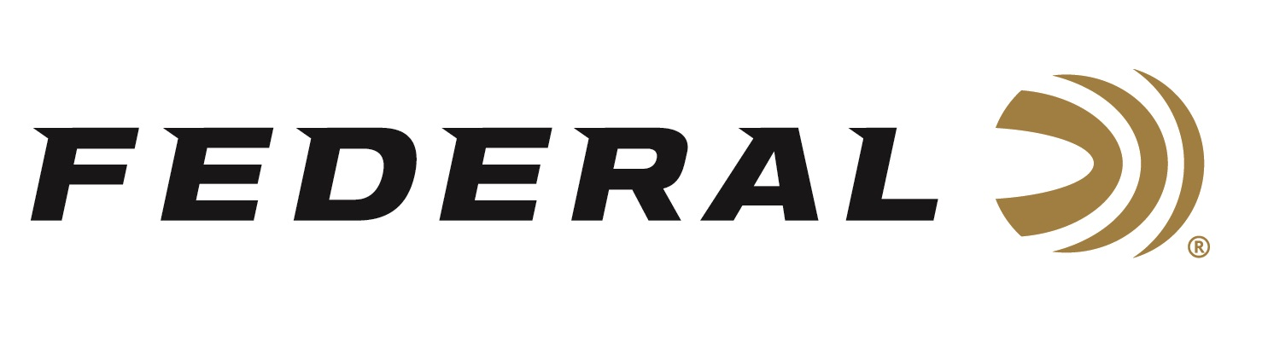

FOR IMMEDIATE RELEASE

**Federal Ammunition Launches Three New Shotshell Rebates for Fall**

**ANOKA, Minnesota – August 5, 2025** — Federal Ammunition has announced three new rebate promotions to help hunters save on a wide range of high-performance shotgun loads. The limited-time offers—Slug Some Bucks, Premium® Waterfowl Rebate, and Save on Steel—run from August 1 through December 31, 2025, and provide opportunities to earn up to $200 back on qualifying purchases.

“With these rebates, hunters can save big while stocking up on some of our most trusted and innovative shotgun loads,” said Federal’s Director of Trade Marketing, Jill Karolewski. “Whether you're chasing waterfowl across the marsh or deer in the woods or fields, there's a rebate here to help you gear up for success this season.”

**The Slug Some Bucks rebate** offers customers up to $60 back when they purchase at least two boxes of select Federal hunting slug ammunition and receive 20% of the purchase price. Eligible products include Freight Train Copper Sabot, Power-Shok Rifled, Power-Shok Sabot, Shorty Shells Rifled, Trophy Copper Sabot, TruBall Rifled, and TruBall Deep Penetrator Rifled.

**The Premium Waterfowl rebate** offers waterfowlers up to $200 back with a $5-per-box rebate on select Federal Premium shotshell products. Qualifying loads include: Black Cloud FS Steel, Black Cloud High Velocity, Black Cloud TSS, Ultra Steel, and Premium featuring HEVI-Bismuth.

**The Save on Steel rebate** provides a $2-per-box rebate and up to $100 back on select Federal waterfowl steel shotshells. Eligible products include: Speed-Shok, Speed-Shok Sea Duck, Speed-Shok Snow Goose, and Rob Roberts Raptor Steel.

All purchases must be made between August 1 and December 31, 2025. Only select products are eligible—see the official terms and conditions to learn more. For complete rebate details, visit: <https://www.federalpremium.com/this-is-federal/rebates-and-promotions.html>.

Federal Ammunition products are available at dealers nationwide and online. For more information on all Federal products and to sign up for notifications about new product availability, rebate promotions, and other brand news via email, visit [www.federalpremium.com](http://www.federalpremium.com).  
  
**Press Release Contact:** JJ Reich  
Senior Manager – Press Relations  
E-mail: [media@tkghunt.com](mailto:media@tkghunt.com)

**About Federal Ammunition**

Federal, headquartered in Anoka, MN, is an ammunition brand of The Kinetic Group, owned by CSG, a globally diversified industrial group based in Prague, Czech Republic. Since 1922, Federal has been a leader in ammunition innovation, delivering high-quality sporting and hunting products to shooters worldwide. With a commitment to conservation and the outdoor community, Federal continues to manufacture industry-leading ammunition that enhances the shooting experience while supporting outdoor traditions.