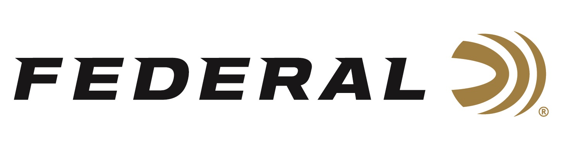

FOR IMMEDIATE RELEASE

**Federal Ammunition Received the 2025 National 4-H Shooting Sports Pioneer Award**

**ANOKA, Minnesota – July 16, 2025 –** Federal Ammunition was recently honored with the 2025 4-H Shooting Sports Pioneer Award, which recognizes individuals or companies that have made significant contributions to the 4-H Shooting Sports program at a national level. The recipients of the award are honored for their exceptional dedication, leadership, and vision in promoting the program's growth and development.

“It is my honor to recognize Federal Ammunition, a truly remarkable legacy of support,” said Scott Stuhr, National 4-H Shooting Sports Program Coordinator. “From the very beginning of when the national 4-H Shooting Sports Program was conceptualized in the late 1970s, Federal Ammunition has played a vital role in helping develop, guide, and sustain it. Since its official start in 1980, Federal has been our longest continuous donor, over four decades of unwavering support that has impacted millions of young people nationwide. This award is a tribute to that lasting commitment and vision.”

“We, at Federal, are extremely honored to be recognized with the National 4-H Shooting Sports Pioneer Award,” Jon Zinnel, Director of Community Relations for Federal Ammunition. “This award celebrates our long-term involvement and commitment, especially in helping to develop new initiatives, expanding opportunities for youth participation, or securing resources to support the program. The core values of 4-H Shooting Sports match what our company also holds in high regard, such as safety, responsibility, sportsmanship, and positive youth development within shooting sports. We are extremely proud of this award.”

Federal Ammunition products are available at dealers nationwide and online. For more information on all Federal products and to sign up to receive notifications about new product availability, rebate promotions, and other brand news via email, visit [www.federalpremium.com](http://www.federalpremium.com).

**Press Release Contact:** JJ Reich  
Senior Manager – Press Relations  
E-mail: [media@tkghunt.com](mailto:media@tkghunt.com)

**About Federal Ammunition**

Federal, headquartered in Anoka, MN, is an ammunition brand of The Kinetic Group, owned by CSG, a globally diversified industrial group based in Prague, Czech Republic. Since 1922, Federal has been a leader in ammunition innovation, delivering high-quality sporting and hunting products to shooters worldwide. With a commitment to conservation and the outdoor community, Federal continues to manufacture industry-leading ammunition that enhances the shooting experience while supporting outdoor traditions.