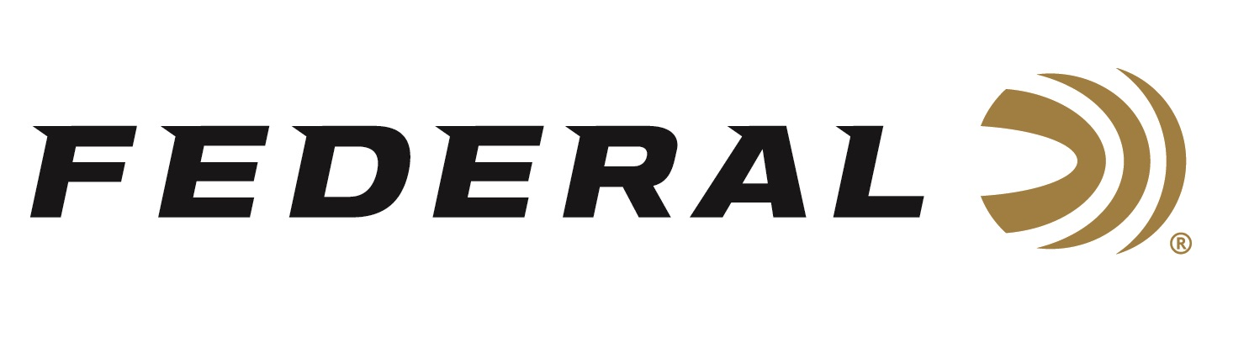

FOR IMMEDIATE RELEASE

**Federal’s New 7mm Backcountry Terminal Ascent 155-Grain Loads Now Shipping**

**ANOKA, Minnesota – July 25, 2025 –** Federal Ammunition launched 7mm Backcountry earlier this year, and retailers are stocking shelves with this revolutionary technology. This ground-breaking long-action hunting cartridge raises the bar for what a non-magnum, centerfire rifle hunting load can achieve. Federal Premium®Terminal Ascent 155-grain 7mm Backcountry loads are currently being delivered to retailers nationwide.

[Terminal Ascent 7mm Backcountry Ammo | 155 Grain, 3300 FPS](https://www.federalpremium.com/rifle/terminal-ascent/11-P7BCTA1.html)

Federal Premium Terminal Ascent Bonded construction penetrates deep on close targets, while the patented Slipstream polymer tip initiates expansion at velocities 200 fps lower than comparable designs. The bullet's long, sleek profile offers an extremely high ballistic coefficient, and its AccuChannel groove technology improves accuracy and minimizes drag. The company touts this popular hunting bullet as the best-performing hunting projectiles it has ever built. Federal offers its 7mm Backcountry cartridge in both 155- and 170-grain Terminal Ascent bullet options.

“The 155-grain Terminal Ascent bullet has a high G1 Ballistic Coefficient of .586,” said Eric Miller, Federal’s Centerfire Rifle Product Line Manager. “Our 155-grain load is the fastest 7mm on the market with 3,150 fps out of a 20-inch barrel, and 3,300 fps out of a 24-inch barrel.”

Federal’s 7mm Backcountry is a new high-performance hunting cartridge boosted by all-new, patented one-piece, high-strength Peak Alloy case technology, which provides magnum performance in a standard bolt face rifle. Through 20-inch barrels and with 170-grain bullets, it can achieve 3,000 feet per second. To learn more, visit <https://www.federalpremium.com/backcountry.html>.

**Part No. / Description / MSRP**

P7BCTA1 / 7mm Backcountry 155-Grain Terminal Ascent / $78.99

P7BCTA3 / 7mm Backcountry 170-Grain Terminal Ascent / $78.99

Federal Ammunition products are available at dealers nationwide and online. For more information on all Federal products and to sign up for notifications about new product availability, rebate promotions, and other brand news via email, visit [www.federalpremium.com](http://www.federalpremium.com).

**Press Release Contact:** JJ Reich  
Senior Manager – Press Relations  
E-mail: [media@tkghunt.com](mailto:media@tkghunt.com)

**About Federal Ammunition**

Federal, headquartered in Anoka, MN, is an ammunition brand of The Kinetic Group, owned by CSG, a globally diversified industrial group based in Prague, Czech Republic. Since 1922, Federal has been a leader in ammunition innovation, delivering high-quality sporting and hunting products to shooters worldwide. With a commitment to conservation and the outdoor community, Federal continues to manufacture industry-leading ammunition that enhances the shooting experience while supporting outdoor traditions.