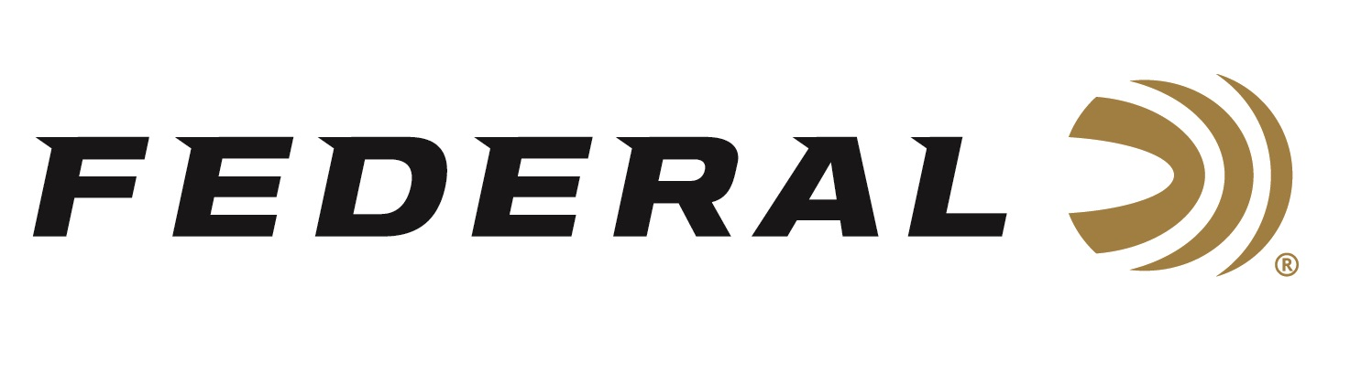

FOR IMMEDIATE RELEASE

**Federal’s New 7mm Backcountry Elite Hunter 195-Grain Loads Now Shipping**

**ANOKA, Minnesota – July 17, 2025 –** Federal Ammunition launched 7mm Backcountry earlier this year, and retailers are stocking shelves with this revolutionary technology. This ground-breaking long-action hunting cartridge raises the bar for what a non-magnum, centerfire rifle hunting load can achieve. Federal Premium® Elite Hunter 195-grain 7mm Backcountry loads are currently being delivered to retailers nationwide.

[Elite Hunter 7mm Backcountry Ammo | 195 Grain, 3000 FPS](https://www.federalpremium.com/rifle/elite-hunter/11-P7BCEH1.html)

The Berger Elite Hunter offers some of the industry’s highest ballistic coefficients in a hunting bullet, and its thin-jacket design produces extreme hydrostatic shock and a massive wound cavity on impact. Loaded with Premium components to incredibly tight tolerances, the loads produce lethal accuracy at extended distances. Available in Federal’s all-new 7mm Backcountry cartridge, which provides magnum performance through compact, shorter-barreled, suppressed hunting rifles.

“We specifically designed all the dimensions of this new cartridge to be able to accept the longest, heaviest bullets the current marketplace has to offer, such as this one from Berger,” said Eric Miller, Federal's Centerfire Rifle Product Line Manager. “The Berger Elite Hunter’s thin jacket produces effective shock and wound cavity on impact. This 195-grain bullet achieves 2,850 fps out of a 20-inch barrel and has a G1 BC of .755.”

Federal’s 7mm Backcountry is a new high-performance hunting cartridge boosted by all-new, patented one-piece, high-strength Peak Alloy case technology, which provides magnum performance in a standard bolt face rifle. Through 20-inch barrels and with 170-grain bullets, it can achieve 3,000 feet per second. To learn more, visit <https://www.federalpremium.com/backcountry.html>.

**Part No. / Description / MSRP**

P7BCEH1 / 7mm Backcountry, 195 Grain, 2850 fps (20" Barrel), 3000 fps (24") / $80.99

Federal Ammunition products are available at dealers nationwide and online. For more information on all Federal products and to sign up for notifications about new product availability, rebate promotions, and other brand news via email, visit [www.federalpremium.com](http://www.federalpremium.com).

**Press Release Contact:** JJ Reich  
Senior Manager – Press Relations  
E-mail: [media@tkghunt.com](mailto:media@tkghunt.com)

**About Federal Ammunition**

Federal, headquartered in Anoka, MN, is an ammunition brand of The Kinetic Group, owned by CSG, a globally diversified industrial group based in Prague, Czech Republic. Since 1922, Federal has been a leader in ammunition innovation, delivering high-quality sporting and hunting products to shooters worldwide. With a commitment to conservation and the outdoor community, Federal continues to manufacture industry-leading ammunition that enhances the shooting experience while supporting outdoor traditions.