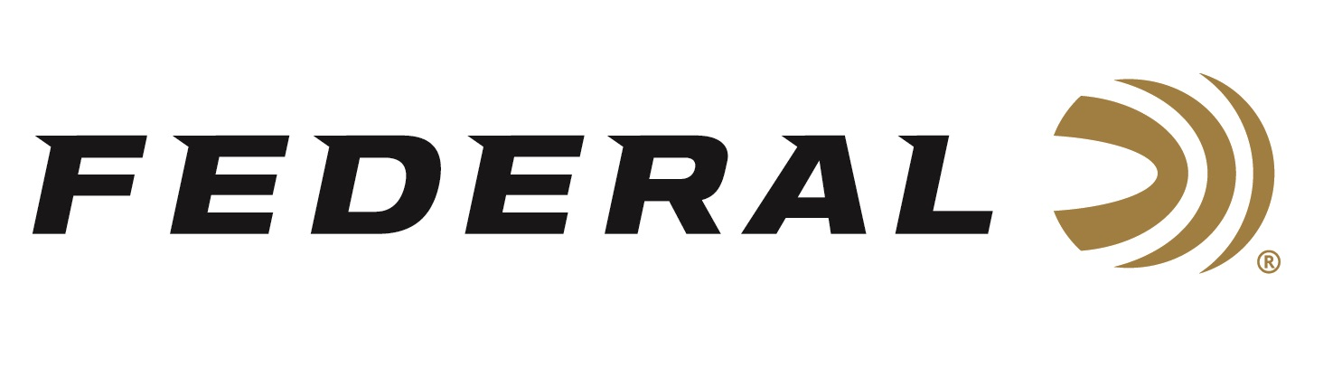

FOR IMMEDIATE RELEASE

**Federal’s New 7mm Backcountry Fusion Tipped and LRX Loads Now Shipping**

**ANOKA, Minnesota – February 19, 2025 –** Federal Ammunition recently launched 7mm Backcountry and retailers are now stocking shelves with this revolutionary technology. This ground-breaking long-action hunting cartridge raises the bar for what a non-magnum, centerfire rifle hunting load can achieve. Fusion Tipped 175-grain and LRX 168-grain 7mm Backcountry loads are currently being delivered to retailers nationwide.

Federal’s 7mm Backcountry is a new high-performance hunting cartridge boosted by all-new, patented one-piece, high-strength Peak Alloy case technology, which provides magnum performance in a standard bolt face rifle. Through 20-inch barrels and with 170-grain bullets, it can achieve 3,000 feet per second. To learn more, visit <https://www.federalpremium.com/backcountry.html>.

The Federal-engineered Fusion Tipped 175-grain option will be popular among hunters already familiar with the Fusion lines of reliable, accurate big-game ammunition.

“Fusion Tipped was just released last year yet was born from its extremely popular Fusion soft-point cousin,” explained Miller. “Fusion’s molecular bonding paired with a streamlined polymer tip gives Fusion Tipped 7mm Backcountry the ability to go the distance and deliver a devastating blow to big game. This 175-grain bullet achieves 2,975 fps from a 20-inch barrel and has a G1 BC of .575.”

Federal’s Barnes LRX 168-grain load is specifically for those looking for an all-copper option.

“Armed with a high ballistic coefficient, polymer tip, and unique nose cavity, the all-copper LRX takes down tough game at both close range and extended distances,” continued Miller. “Barnes is a well-known, well-established brand that needs little explanation. This 168-grain bullet achieves 3,000 fps from a 20-inch barrel and has a G1 BC of .513.”

**Part No. / Description / MSRP**

F7BCTFS2 / 7MM Backcountry 175-grain Fusion Tipped / $62.99

P7BCLRX1 / 7MM Backcountry 168-grain Barnes LRX / $81.99

Federal Ammunition products can be found at dealers nationwide and online. For more information on all products from Federal, visit [www.federalpremium.com](http://www.federalpremium.com).

**Press Release Contact:** JJ Reich

Senior Manager – Press Relations

E-mail: media@tkghunt.com

**About Federal Ammunition**

Federal, headquartered in Anoka, MN, is an ammunition brand of The Kinetic Group, owned by CSG, a globally diversified industrial group based in Prague (Czech Republic). From humble beginnings nestled among the lakes and woods of Minnesota, Federal Ammunition has evolved into one of the world's largest producers of sporting ammunition. In 1922, founding President Charles L. Horn paved the way for our success. Today, Federal carries on Horn's vision for quality products and services with the next generation of outdoorsmen and women. We maintain our position as experts in the science of ammunition production. Every day, Federal manufactures products to enhance our customers' shooting experience while partnering with the conservation organizations that protect and support our outdoor heritage. Federal offers thousands of options in our Federal Premium® and standard Federal® lines, making it the most complete ammunition company in the business and helping it provide customers with a choice no matter what the pursuit.