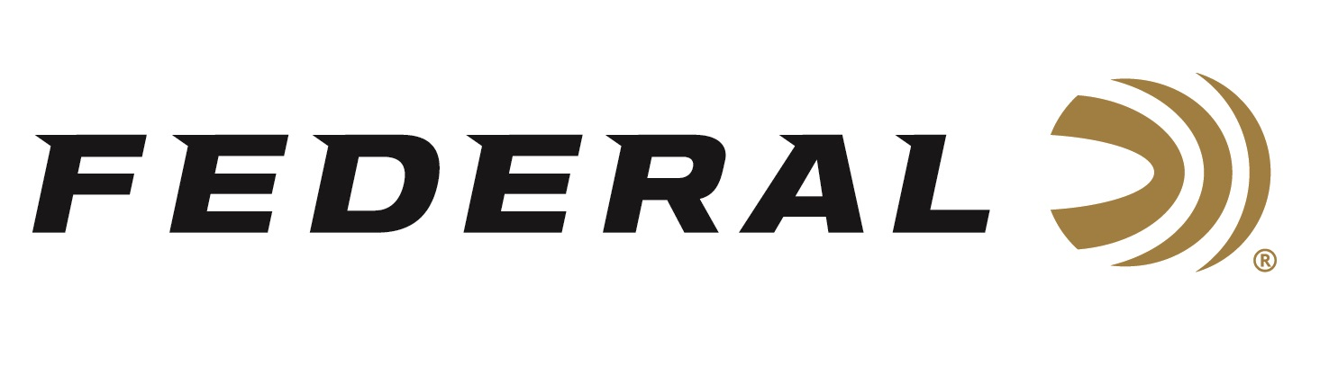

FOR IMMEDIATE RELEASE

**Federal’s New American Eagle 32 H&R Loads Now Shipping**

**ANOKA, Minnesota – April 1, 2025 –** Federal Ammunition recently added a new 32 H&R 85-grain Jacketed Soft Point (JSP) load to its American Eagle handgun ammunition product line. The new product is ideal for training and target shooting with 32 H&R handguns or as a reduced-recoil option for 327 Federal Magnum handguns. The new load is currently being delivered to retailers nationwide.

[American Eagle Handgun, 32 H&R Magnum, 85 Grain, Jacketed Soft Point](https://www.federalpremium.com/handgun/american-eagle-handgun/11-AE32HR.html)

“This new 32 H&R 85-grain JSP load is a perfect target shooting and training load for use with all the new guns from Smith & Wesson, Ruger, Taurus, and more,” said Chris Laack, Federal Handgun Ammunition Product Manager. “It provides recoil and velocities similar to those of self-defense, offering a familiar feel and realistic practice.”

This new handgun load features clean-burning powders, reliable Federal primers, reloadable brass cases, and quality, accurate bullets, and is sold in 50-count boxes.

**Part No. / Description / MSRP**

AE32HR / 32 H&R Magnum, 85 grain, Jacketed Soft Point, 975 FPS / $47.99

Federal Ammunition products are available at dealers nationwide and online. For more information on all Federal products and to sign up to receive notifications about new product availability, rebate promotions, and other brand news via email, visit [www.federalpremium.com](http://www.federalpremium.com).

**Press Release Contact:** JJ Reich

Senior Manager – Press Relations

E-mail: media@tkghunt.com

**About Federal Ammunition**

Federal, headquartered in Anoka, MN, is an ammunition brand of The Kinetic Group, owned by CSG, a globally diversified industrial group based in Prague (Czech Republic). From humble beginnings nestled among the lakes and woods of Minnesota, Federal Ammunition has evolved into one of the world's largest producers of sporting ammunition. In 1922, founding President Charles L. Horn paved the way for our success. Today, Federal carries on Horn's vision for quality products and services with the next generation of outdoorsmen and women. We maintain our position as experts in the science of ammunition production. Every day, Federal manufactures products to enhance our customers' shooting experience while partnering with the conservation organizations that protect and support our outdoor heritage. Federal offers thousands of options in its Federal Premium® and standard Federal® lines, making it the most comprehensive ammunition company in the business and helping it provide customers with a choice for every pursuit.