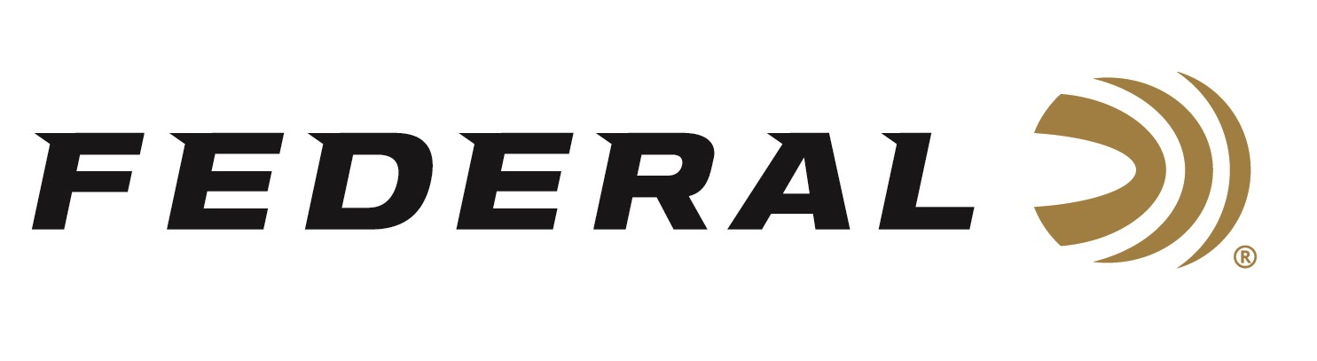

FOR IMMEDIATE RELEASE
Federal Ammunition’s Black Pack Rebate Returns for Black Friday
ANOKA, Minnesota – November 24, 2025 – Federal Ammunition is proud to announce the return of its Black Pack rebate program. Just in time for Black Friday and the upcoming holidays, customers can purchase qualifying Federal Black Pack ammunition and receive a $7.50 rebate per box.
“Back for Black Friday, the Black Pack rebate gives customers a great way to stock up on dependable, high-volume ammunition,” said Federal’s Senior Manager of Trade Marketing Bart Biedinger. “Whether for range days or gifting, Black Pack ammo is a great value—and this promotion makes it even better.”
Rebate details include buying a minimum of one (1) qualifying box of promotional Federal® Black Pack™ ammunition and receiving $7.50 back per box. A maximum rebate of $100 per person or household applies to the program.
Valid purchase dates run from November 22, 2025, through December 5, 2025. The deadline for online submission is December 31, 2025. Online submission is fast and easy using a computer, tablet, or mobile device.
For complete rebate details, visit: Rebates & Promotions.
Federal Ammunition products are available at dealers nationwide and online. For more information on all Federal products and to sign up for notifications about new product availability, rebate promotions, and other brand news via email, visit www.federalpremium.com.

Press Release Contact: JJ Reich
Senior Manager – Press Relations
E-mail: media@tkghunt.com

About Federal Ammunition
Federal, headquartered in Anoka, MN, is an ammunition brand of The Kinetic Group, owned by CSG, a globally diversified industrial group based in Prague, Czech Republic. Since 1922, Federal has been a leader in ammunition innovation, delivering high-quality sporting and hunting products to shooters worldwide. With a commitment to conservation and the outdoor community, Federal continues to manufacture industry-leading ammunition that enhances the shooting experience while supporting outdoor traditions.

