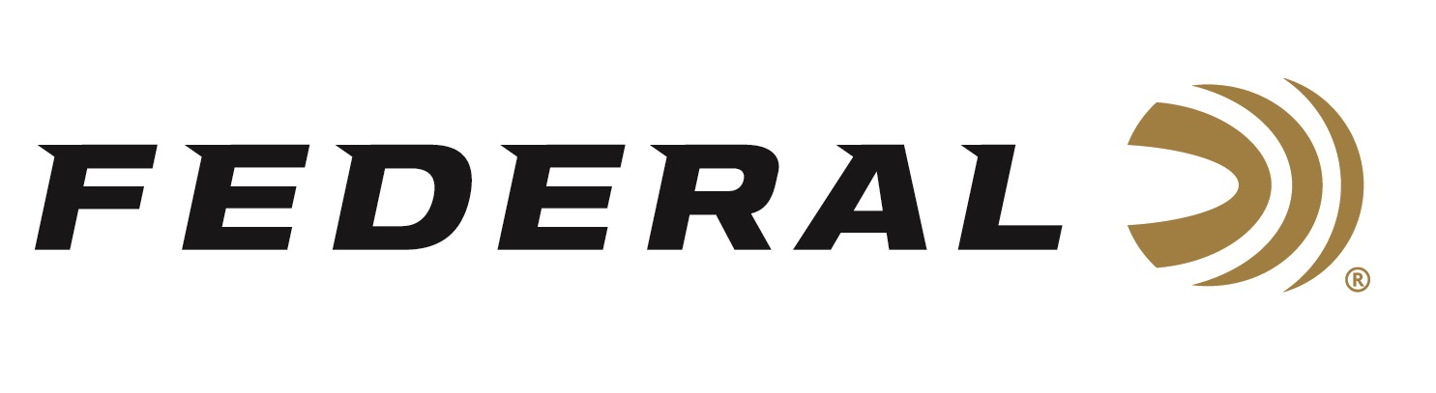
FOR IMMEDIATE RELEASE

Federal Ammunition Supports the Boone and Crockett Club’s Poach and Pay Project

ANOKA, Minnesota – October 31, 2025 – Federal Ammunition is proud to continue supporting the Boone and Crockett Club (B&C) through its Trailblazer in Conservation sponsorship as an Industry Sponsor. This included supporting B&C’s extensively researched Poach and Pay Program unveiled earlier this fall.

“We have long known that poaching is a major problem in the United States, but we didn’t truly understand the magnitude of the problem until this Poach and Pay research,” said B&C’s Chief Executive Officer Tony A. Schoonen. “With this defensible assessment, we can clearly describe the conservation cost of poaching and prove that poaching is not a victimless crime—not only do we lose individual wildlife, we are also losing a valuable public resource with a high cost.”

B&C recently released its 2025 Poach and Pay program research on its website. This included handouts and posters developed to promote the program’s research and to continue educating online and social media audiences about its statistics and significant findings. Learn more at: www.boone-crockett.org/poach-and-pay.

“Trailblazers in Conservation continues to represent a commitment from industry partners and others that support the mutual interests of science-supported wildlife management and conservation, as well as hunter ethics and advocacy,” commented Federal’s Conservation Director, Jon Zinnel. “However, this year, we appreciated the organization’s focus on building more assets to promote the Poach & Pay project. We believe this commitment to finding the real cost of wildlife crimes and helping develop policies that will deter future crimes is essential to show the difference between law-abiding hunters and poachers clearly.”

The Boone and Crockett Club is the oldest conservation organization in the country and supports all forms of big-game hunting. Throughout its 134-year history, strategic partnerships, such as its sponsorship from Federal Ammunition, have contributed to many of the club's accomplishments. Learn more at www.boone-crockett.org.

Federal Ammunition products are available at dealers nationwide and online. For more information on all Federal products and to sign up for notifications about new product availability, rebate promotions, and other brand news via email, visit www.federalpremium.com
Press Release Contact: JJ Reich
Senior Manager – Press Relations
E-mail: media@tkghunt.com

About Federal Ammunition
Federal, headquartered in Anoka, MN, is an ammunition brand of The Kinetic Group, owned by CSG, a globally diversified industrial group based in Prague, Czech Republic. Since 1922, Federal has been a leader in ammunition innovation, delivering high-quality sporting and hunting products to shooters worldwide. With a commitment to conservation and the outdoor community, Federal continues to manufacture industry-leading ammunition that enhances the shooting experience while supporting outdoor traditions.

