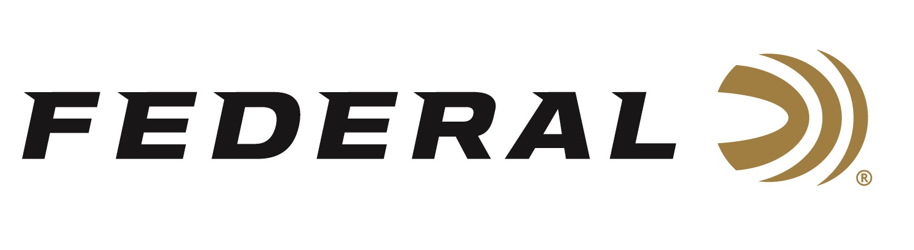

FOR IMMEDIATE RELEASE

Federal Custom Shop Introduces Six New Turkey Loads

ANOKA, Minnesota – November 25, 2025 – Federal Custom Shop offers expertly handloaded ammunition, built to order with the highest-quality components. It has recently added six new turkey-load options to its overall TSS shotshell lineup. Custom Shop loads are for hunters seeking specific loading options not available in factory-loaded ammunition.

The six new loads are two 3-inch 12-gauge, 2-1/2-ounce in No. 7 and 9 shot options; two 2-3/4-inch 12-gauge, 2-1/4-ounce in No. 7 and 9 shot options; and two 3-inch 28-gauge 1-11/16-ounce in No. 7 and 9 shot options.

“Launched in the fall of 2019, the product line in our Federal Custom Shop continues to grow,” said Federal Shotshell Product Manager Josh Vickers. “This year, we have added several options of Tungsten Super Shot (TSS) with hefty payloads to deliver maximum pellet counts. These are the types of ultra-heavy payload shotshells that we can’t load on our factory machines effectively and efficiently. They really can only be built as handloads, so we are happy to offer them as Custom Shop offering.”

The Federal Ammunition factory is located in Anoka, Minnesota. Its online Custom Shop is a separate, secure room within, featuring a state-of-the-art reloading workshop focused on the utmost attention to detail, quality, and care for each hand-loaded round. An elite group of the Federal’s most experienced employees was selected to work in the Custom Shop. Using the best components available, these expert engineers handcraft this ammunition to order. Each round is hand-checked, then cleaned and inspected, before being packed in Custom Shop packaging and shipped out. Each box of Custom Shop ammunition is signed by the Federal employee who hand-loaded it.

A dedicated page on www.federalpremium.com takes Custom Shop users to an order form, where they select their ammunition options and preferences, then purchase the custom ammunition via credit card. Since ammo is made-to-order, the typical lead time is approximately 2 to 3 weeks. Buyers will receive their order within a few days of shipping.

Federal Ammunition products are available at dealers nationwide and online. For more information on all Federal products and to sign up for notifications about new product availability, rebate promotions, and other brand news via email, visit www.federalpremium.com.
Press Release Contact: JJ Reich
Senior Manager – Press Relations
E-mail: media@tkghunt.com

About Federal Ammunition
Federal, headquartered in Anoka, MN, is an ammunition brand of The Kinetic Group, owned by CSG, a globally diversified industrial group based in Prague, Czech Republic. Since 1922, Federal has been a leader in ammunition innovation, delivering high-quality sporting and hunting products to shooters worldwide. With a commitment to conservation and the outdoor community, Federal continues to manufacture industry-leading ammunition that enhances the shooting experience while supporting outdoor traditions.

