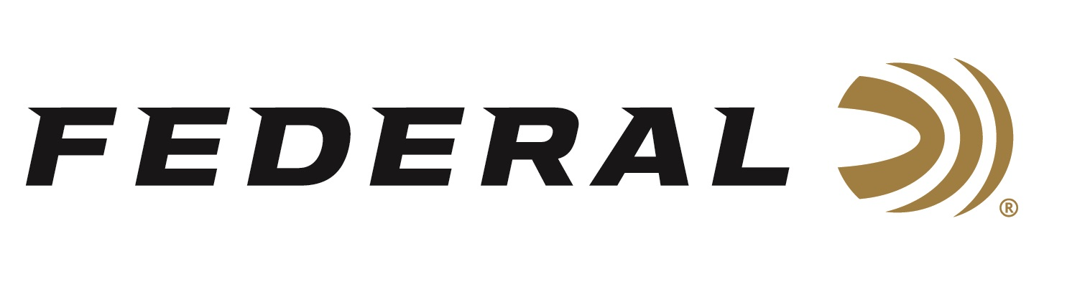

FOR IMMEDIATE RELEASE

**Federal Sponsored Shooter Debbie Ohye-Neilson Dominates Again at the 2025 Grand American**

**ANOKA, Minnesota –** **August 19, 2025 –** Federal Ammunition congratulates sponsored-shooter Debbie Ohye-Neilson on a long list of championship wins at the recent Grand American World Trapshooting Championships, held in Sparta, Illinois, at the World Shooting & Recreational Complex. The 126th annual event, presented by the Amateur Trapshooting Association (ATA), drew nearly 5,000 competitors and ran from July 30 to August 9, 2025.

Debbie was the Lady II Champion at the following nine events: ATA 2600 HOA, Excel Bottling Company Super 500 Doubles, Graf & Sons Doubles, Kubota Doubles, Litte Egypt Golf Cars Doubles, NRA Singles, Precision Fit Stocks Doubles, HOA 1500, Super 500 Singles, and more, including several Lady II Runner-up and Lady II Third titles.

In general, Debbie attributes her successful trapshooting career to hard work, consistency, and dedication to the sport. Debbie is a member of the ATA Hall of Fame with more than four hundred trophies spanning more than four decades of competing. She has also been an ATA All-American for 38 straight years, with 26 of those years being Captain of her respected category.

“Competing in ATA events has been an experience,” Debbie said. “It has made my life fulfilled. I’m grateful for the people I’ve met, shot with, and became friends with, throughout all these years. I’m glad my choices brought me to where I am.”

Debbie chooses Federal’s Top Gun in No. 8 for Singles and Doubles and relies on Federal Gold Medal Paper in No. 7.5 when shooting Handicap. The look, feel, and performance of Gold Medal Paper shotshells have made them the favorite of the most serious clay target shooters. Now they're even better, thanks to a high-quality brass head, harder shot, and modern wad options.

Federal manufactures products in America for all competitive and recreational disciplines and is a top choice for competition shotgun shells, which include the High Over All, Gold Medal Paper, and new-for-2025 Federal’s Master Class and All-American product lines.

Federal Ammunition products are available at dealers nationwide and online. For more information on all Federal products and to sign up for notifications about new product availability, rebate promotions, and other brand news via email, visit [www.federalpremium.com](http://www.federalpremium.com).

**Press Release Contact:** JJ Reich  
Senior Manager – Press Relations  
E-mail: [media@tkghunt.com](mailto:media@tkghunt.com)

**About Federal Ammunition**

Federal, headquartered in Anoka, MN, is an ammunition brand of The Kinetic Group, owned by CSG, a globally diversified industrial group based in Prague, Czech Republic. Since 1922, Federal has been a leader in ammunition innovation, delivering high-quality sporting and hunting products to shooters worldwide. With a commitment to conservation and the outdoor community, Federal continues to manufacture industry-leading ammunition that enhances the shooting experience while supporting outdoor traditions.