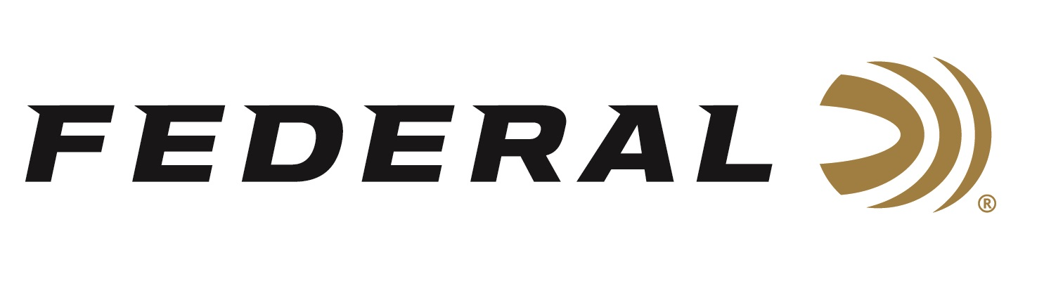

FOR IMMEDIATE RELEASE

**Federal Ammunition is the Official Presenting Sponsor of the 2025 Delta Waterfowl Duck Hunters Expo**

**ANOKA, Minnesota –** **July 23, 2025 –** Federal Ammunition continues its support of Delta Waterfowl, The Duck Hunters Organization as the Presenting Sponsor of the 2025 Delta Waterfowl Duck Hunters Expo. The event will take place from July 25 to 27 at the Oklahoma City Fairgrounds in Oklahoma City, Oklahoma. Visitors can stop by the Federal booth No. 303 to see the latest and greatest products from Federal.

“Federal is proud to return as the presenting sponsor of this annual event, as Delta Waterfowl is a vital conservation partner for us and dedicated to putting more ducks over decoys,” said Josh Vickers, Federal’s Shotshell Product Manager. “We look forward to seeing our customers and celebrating waterfowl hunting. We continue to produce the highest quality American-made ammunition and ensure our customers have the best time while on their pursuits in the marsh, on the lake, or in the field.”

Federal Ammunition has recently launched a new waterfowl hunting ammunition line in Rob Roberts Raptor Steel. Federal’s shotshell engineers collaborated with experts at the Rob Roberts Custom Gunworks to design these specialized waterfowl loads, which pair heavy payloads and high shot counts to put more pellets on target through Raptor Series chokes. Its heavy 1 3/8-ounce payload is set at an ideal speed of 1,400 fps and produces effective, consistent pattern.

“We encourage all attendees to stop by our booth to sign up for some great prizes including our new Rob Roberts Raptor Steel,” said Vickers. “Attendees can also check out the latest waterfowl hunting gear, watch seminars from industry experts, participate in calling contests, raffles, and more.”

Federal Ammunition products are available at dealers nationwide and online. For more information on all Federal products and to sign up for notifications about new product availability, rebate promotions, and other brand news via email, visit [www.federalpremium.com](http://www.federalpremium.com).

**Press Release Contact:** JJ Reich  
Senior Manager – Press Relations  
E-mail: [media@tkghunt.com](mailto:media@tkghunt.com)

**About Federal Ammunition**

Federal, headquartered in Anoka, MN, is an ammunition brand of The Kinetic Group, owned by CSG, a globally diversified industrial group based in Prague, Czech Republic. Since 1922, Federal has been a leader in ammunition innovation, delivering high-quality sporting and hunting products to shooters worldwide. With a commitment to conservation and the outdoor community, Federal continues to manufacture industry-leading ammunition that enhances the shooting experience while supporting outdoor traditions.