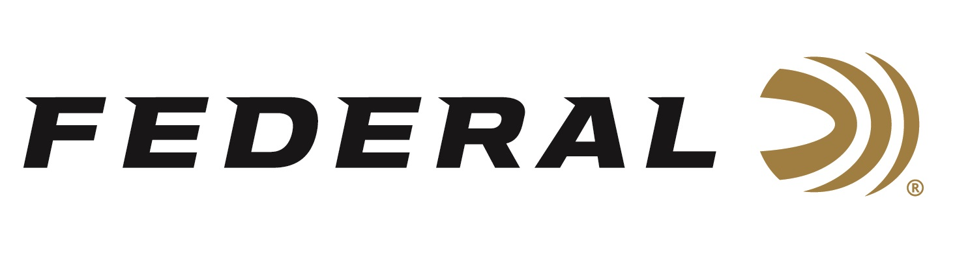

FOR IMMEDIATE RELEASE

**Federal Custom Shop Adds New 28-Gauge and Heavier 12-Gauge TSS Turkey Loads**

**ANOKA, Minnesota – April 15, 2025** – As turkey seasons kick off across the country, Federal Ammunition has expanded its Custom Shop offerings with the addition of two new 28-gauge and four new 12-gauge TSS loads, providing even more flexibility for hunters seeking to elevate their performance. These latest additions are now available exclusively through the Federal Custom Shop.

<https://www.federalpremium.com/custom-shop/custom-shotshell/>

“The Custom Shop is designed to cater to hunters seeking a hard-to-find, specialized load—something that may not always be readily available on the shelf,” said Joshua Vickers, Shotshell Product Line Manager for Federal Ammunition. “With the addition of these new 28-gauge and 12-gauge options, we’re expanding our ability to provide turkey hunters with precision-loaded, ultra-dense TSS rounds tailored to their specific needs and preferences—all with the same performance and quality they expect from the Custom Shop.”

The Federal Custom Shop offers Tungsten Super Shot (TSS) loads in a wide range of gauges, payloads, and shot sizes, including options not found in the standard product catalog. All of the newly added turkey loads are offered in either shot size 7 or 9.

The new 28-gauge loads are 3-inch shells that deliver an increased payload capacity and enhanced performance for hunters seeking to maximize their effective range. 2¾-inch, 28-gauge turkey loads were already existing in the Custom Shop lineup.

The new heavier-payload 12-gauge shotshells are available in both 2¾-inch and 3-inch shell lengths, offering hunters more flexibility to match their preferred firearm setup without compromising pattern density or energy downrange. 12-gauge turkey loads with lesser payload weights, or 3-1/2-inch hulls were already existing in the Custom Shop lineup.

Custom Shop ammunition is crafted inside a secured, state-of-the-art workshop within the Federal Ammunition factory in Anoka, Minnesota. Each round is hand-loaded by a select team of Federal’s most experienced professionals using top-tier components. Every shell is inspected, cleaned, and packaged with care—complete with the signature of the technician who built it. They are sold in 10-count boxes.

**Part No. / Description / MSRP**FCST283 7 / Custom Shop TSS, 28 Gauge, 3-inch, 1 11/16-ounce No. 7 / $125.99  
FCST283 9 / Custom Shop TSS, 28 Gauge, 3-inch, 1 11/16-ounce No. 9 / $125.99  
FCST12275225 7 / Custom Shop TSS, 12 Gauge, 2 ¾-inch, 2 ¼-ounce No. 7 / $149.99  
FCST12275225 9 / Custom Shop TSS, 12 Gauge, 2 ¾-inch, 2 ¼-ounce No. 9 / $149.99  
FCST12325 7 / Custom Shop TSS, 12 Gauge, 3-inch, 2 ½-ounce No. 7 / $155.99  
FCST12325 9 /Custom Shop TSS, 12 Gauge, 3-inch, 2 ½-ounce No. 9 / $155.99

Federal Custom Shop ammunition is built to order and is not pulled out of inventory in a warehouse. As such, lead time for processing and delivery is required. Typically, Custom Shop orders take two weeks to build, plus the standard delivery time.

Federal Ammunition products are available at dealers nationwide and online. For more information on all Federal products and to sign up to receive notifications about new product availability, rebate promotions, and other brand news via email, visit [www.federalpremium.com](http://www.federalpremium.com).

**Press Release Contact:**  
JJ Reich  
Senior Manager – Press Relations  
E-mail: [media@tkghunt.com](mailto:media@tkghunt.com)

**About Federal Ammunition**

Federal, headquartered in Anoka, MN, is an ammunition brand of The Kinetic Group, owned by CSG, a globally diversified industrial group based in Prague, Czech Republic. Since 1922, Federal has been a leader in ammunition innovation, delivering high-quality sporting and hunting products to shooters worldwide. With a commitment to conservation and the outdoor community, Federal continues to manufacture industry-leading ammunition that enhances the shooting experience while supporting outdoor traditions.