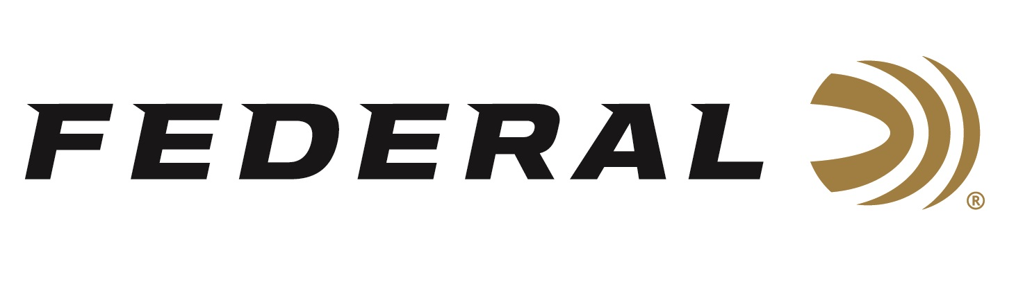

FOR IMMEDIATE RELEASE

**Federal Wins *Predator Xtreme* 2025 Gold Award for Best Shotshells**

**ANOKA, Minnesota** **–** **February 3, 2025 –** Federal has received the 2025 Gold Award in the Shotshells category from the Predator Xtreme readers. Hunters who read this magazine are incredibly loyal to the products they use, and these annual awards allow them to reveal what products they think are the absolute best.

“Federal has proven their Shotshells have phenomenal take down power in the field as well as taking down their competition and winning gold in the Predator Xtreme Readers' Choice Awards, now seven years in a row,” said Predator Xtreme Publisher Derrick Nawrocki. “Predator Xtreme readers can be extremely picky on the gear they choose to use, but more importantly, they are very loyal to the brands they love.”

Varmint Masters magazine was launched in 1994. Around 2000, it changed its name to Predator Xtreme, and in 2025, it will celebrate more than 30 years of publication. Predator Xtreme continues to be the leading predator-hunting brand today, and its popular Readers’ Choice Awards help its audience select the most trusted brands available.

“Federal has long been a fan favorite and continues to be the consistent brand predator hunters trust, year after year,” said Federal Shotshell Product Manager Josh Vickers. “Our Federal Premium Buckshot 4B (P158 4B) is an excellent choice for diehard hunters. We engineer these buckshot shotshells to perform with the same precision as all our other shotshell loads. This load uses copper-plated pellets to produce tight patterns and great downrange energy. It also puts more hits on target for impressive stopping power on predators, hogs, and deer.”

*Predator Xtreme* polled its readership to find out their favorite gear—the products that really work. They then tallied the votes to determine the 2025 Readers' Choice Awards. The awards represent the best insider knowledge on products proven to work best for hunters nationwide. Reporting this knowledge helps their readers become better hunters and spend their hunting gear money wisely.

Federal Ammunition products are available at dealers nationwide and online. For more information on all Federal products, visit [www.federalpremium.com](http://www.federalpremium.com).

**Press Release Contact:** JJ Reich

Senior Manager – Press Relations

E-mail: media@tkghunt.com

**About Federal Ammunition**

Federal, headquartered in Anoka, MN, is an ammunition brand of The Kinetic Group, owned by CSG, a globally diversified industrial group based in Prague (Czech Republic). From humble beginnings nestled among the lakes and woods of Minnesota, Federal Ammunition has evolved into one of the world's largest producers of sporting ammunition. In 1922, founding President Charles L. Horn paved the way for our success. Today, Federal carries on Horn's vision for quality products and services with the next generation of outdoorsmen and women. We maintain our position as experts in the science of ammunition production. Every day, Federal manufactures products to enhance our customers' shooting experience while partnering with the conservation organizations that protect and support our outdoor heritage. Federal offers thousands of options in our Federal Premium® and standard Federal® lines, which is what makes it the most complete ammunition company in the business and helps it provide customers with a choice no matter what the pursuit.