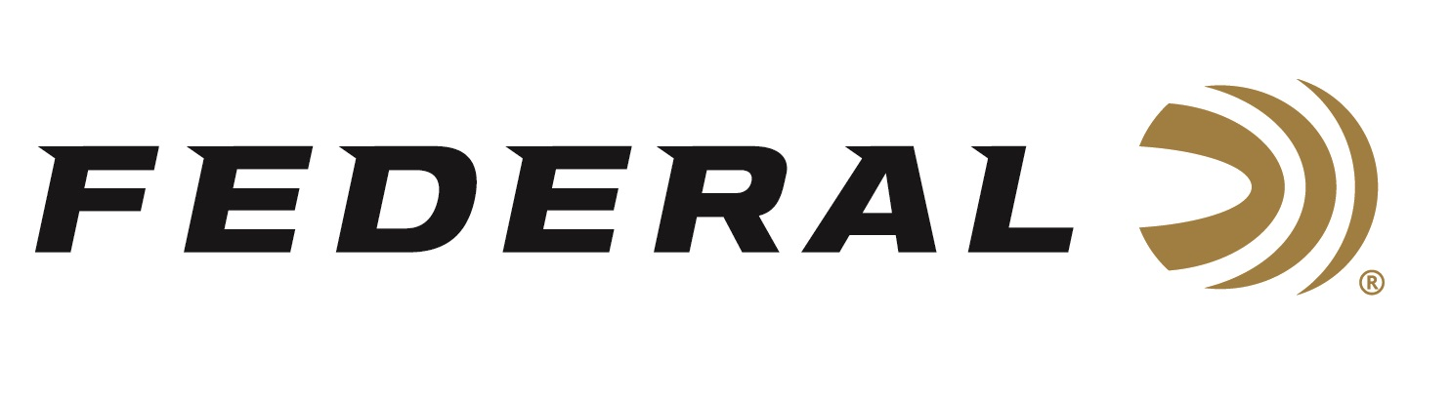

FOR IMMEDIATE RELEASE

**Federal Ammunition Wins 2024 Gold Awards for Best Shotshell**

**ANOKA, Minnesota – April 21, 2025** – The readers of Tactical Retailer and Shooting Sports Retailer have awarded Federal Ammunition the 2024 Gold Award for Best Shotshell. These annual Readers’ Choice Awards are 100 percent reader-driven and represent the most trusted gear and brands among today’s shooting sports professionals and enthusiasts.

“These awards directly reflect the confidence that users across the shooting sports industry place in Federal shotshells,” said Josh Vickers, Shotshell Product Line Manager for Federal Ammunition. “Whether in the field, on the range, or serving those in uniform, our focus has always been on delivering quality, performance, and innovation. Being recognized by the readers who count on our products every day is an honor and a reflection of that commitment.”

Federal has a long-standing reputation for innovative, high-performance shotshells that meet the demands of hunters, competitive shooters, and law enforcement professionals. From the legendary Gold Medal line to cutting-edge offerings like Black Cloud, HEVI-Bismuth, and Custom Shop TSS loads, Federal continues leading the category in technology and trust.

“Federal continues to be a powerhouse in the shotshell category, and our readers have made that clear with this year’s Gold Award,” said Derrick Nawrocki, President and Publisher of Tactical Retailer and Shooting Sports Retailer. “Whether for hunting, sport shooting, or tactical use, Federal consistently delivers the performance and reliability our audience depends on. This recognition speaks to the brand’s long-standing impact and continued innovation in the field.”

Federal Ammunition products are available at dealers nationwide and online. For more information on all Federal products and to sign up for notifications about new product availability, rebate promotions, and other brand news via email, visit [www.federalpremium.com](http://www.federalpremium.com).

**Press Release Contact:** JJ Reich

Senior Manager – Press Relations

E-mail: media@tkghunt.com

**About Federal Ammunition**

Federal, headquartered in Anoka, MN, is an ammunition brand of The Kinetic Group, owned by CSG, a globally diversified industrial group based in Prague (Czech Republic). From humble beginnings nestled among the lakes and woods of Minnesota, Federal Ammunition has evolved into one of the world's largest producers of sporting ammunition. In 1922, founding President Charles L. Horn paved the way for our success. Today, Federal carries on Horn's vision for quality products and services with the next generation of outdoorsmen and women. We maintain our position as experts in the science of ammunition production. Every day, Federal manufactures products to enhance our customers' shooting experience while partnering with the conservation organizations that protect and support our outdoor heritage. Federal offers thousands of options in our Federal Premium® and standard Federal® lines, which is what makes it the most complete ammunition company in the business and helps it provide customers with a choice no matter what the pursuit.