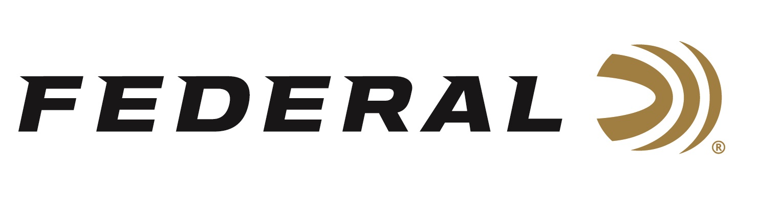

FOR IMMEDIATE RELEASE

**Federal Ammunition Announces an Entirely New Hunting Cartridge: 7mm Backcountry**

**ANOKA, Minnesota – January 7, 2025 –** Federal Ammunition launches a ground-breaking long-action hunting cartridge that raises the bar for what a non-magnum, centerfire rifle hunting load can achieve. The patented Peak Alloy one-piece, high-strength case boosts the new Federal-designed 7mm Backcountry cartridge, which provides magnum performance in a standard bolt face rifle. Through 20-inch barrels and with 170-grain bullets, it can achieve 3,000 feet per second.

Learn more at [Backcountry | Federal Premium](https://www.federalpremium.com/backcountry.html).

“Welcome to the future of rifle cartridges,” said Jesse Whiteside, Federal’s Vice President of Product Management and R&D. “When it comes to innovation in rifle ammunition, as an industry, we have reached a point of diminishing returns with brass cased ammunition. With modern magnums, for example, it may take 30% more propellant to increase velocity by 10%. With our new 7mm Backcountry cartridge, featuring Peak Alloy case technology, those rules are re-written. We can achieve that same 10% velocity increase with less propellant than current magnums and do so out of shorter barrels with less felt recoil. Additionally, unlike conventional magnums, 7mm Backcountry utilizes a standard bolt face which allows for an additional round in the magazine of most hunting rifles. We expect factory gun offerings with barrels as short as 16” that match or outperform today’s current offerings with much longer barrels. This new technology allows hunters and shooters to shoot a barrel with a suppressor on it that is essentially the same length of a barrel without a suppressor on it, in a conventional round today.”

“Hunters are trending toward using shorter-barrel rifles with suppressors,” said Mike Holm, Federal’s Director of Centerfire Rifle Ammunition. “They want a suppressed rifle with a shorter barrel to make it more manageable while on the hunt, but they also want to retain velocities in that 3,000-fps range for flat-shooting performance. At launch, we are loading our new cartridge with some of the industry's best all-range and long-range projectiles to fully exploit its velocity, energy, range, and trajectory advantages.”

“The five initial loads of 7mm Backcountry are 155- and 170-grain Federal Premium Terminal Ascent, 195-grain Federal Premium Berger Elite Hunter, 168-grain Federal Premium Barnes LRX Copper, and 175-grain Federal Fusion Tipped,” said Eric Miller, Federal’s Centerfire Rifle Ammunition Product Line Manager. These flat-shooting, heavy-for-caliber bullets offer the optimal range of options between sleekness and energy, touting high ballistic coefficients.”

Federal’s 7mm Backcountry is an entirely new high-performance, all-range cartridge that reinvents modern ammunition. But achieving this incredible feat is nothing without the tools to ignite it. Federal Ammunition has engaged with many major gun companies while developing 7mm Backcountry, and those manufacturers are working on multiple rifle models chambered for the new cartridge. The new product will be shipping in January 2025.

Federal Ammunition products are available at dealers nationwide and online. For more information on all Federal products, visit [www.federalpremium.com](http://www.federalpremium.com).

**Press Release Contact:** JJ Reich

Senior Manager – Press Relations

E-mail: media@tkghunt.com

**About Federal Ammunition**

Federal, headquartered in Anoka, MN, is an ammunition brand of The Kinetic Group, owned by CSG, a globally diversified industrial group based in Prague (Czech Republic). From humble beginnings nestled among the lakes and woods of Minnesota, Federal Ammunition has evolved into one of the world's largest producers of sporting ammunition. In 1922, founding President Charles L. Horn paved the way for our success. Today, Federal carries on Horn's vision for quality products and services with the next generation of outdoorsmen and women. We maintain our position as experts in the science of ammunition production. Every day, Federal manufactures products to enhance our customers' shooting experience while partnering with the conservation organizations that protect and support our outdoor heritage. Federal offers thousands of options in our Federal Premium® and standard Federal® lines, making it the most complete ammunition company in the business and helping it provide customers with a choice no matter what the pursuit.