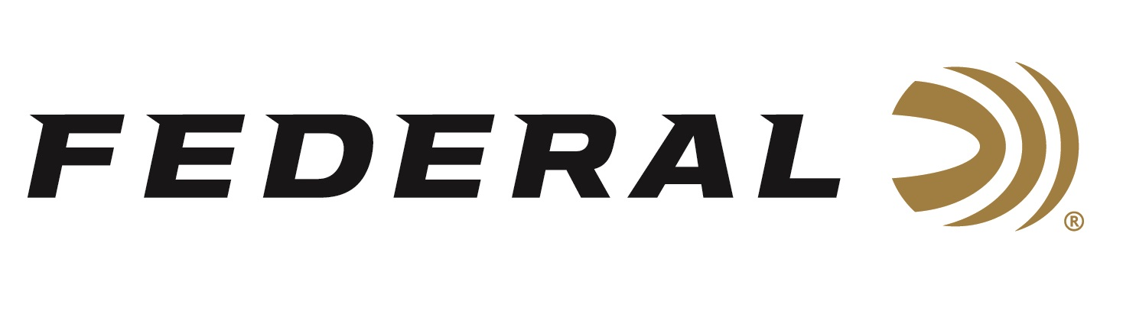

FOR IMMEDIATE RELEASE

**Federal’s All-New Master Class Sporting Clay Shotshell Now Shipping**

**ANOKA, Minnesota – March 12, 2025 –** Federal Ammunition recently launched an all-new shotshell product line: Federal Master Class. This competition-level sporting clay load features a customized Podium wad that extracts peak performance from utilizing Federal’s straight-wall hull, reliable primers, high-antimony lead shot, and select propellant. Federal Master Class loads are currently being delivered to retailers nationwide.

[Master Class | Federal Ammunition](https://www.federalpremium.com/shotshell/master-class/)

“Master Class gives shooters competitively priced loads with top-quality internal components needed to break the most challenging targets in sporting clays and FITASC,” said Federal’s Shotshell Product Line Manager Josh Vickers. “From the unique and attractive blue hull to a new shot sorting process utilized in its loading, this new product line is built to exceed the expectations of all Sporting Clay shooters.”

Master Class features two top-tier components, a one-piece Podium wad and high-antimony lead shot that balances hardness and density. It's constructed with a straight-wall hull, inserted plastic base wad and striated tube for optimum performance.

Master Class offers a much better option than standard target loads for those who compete in Sporting Clays. It features high-quality components in an ultra-reliable two-piece straight-wall hull design and is offered in the most popular payloads and velocities for modern Sporting Clays competitions.

Master Class is packaged in 25-count boxes and is loaded in six 12-gauge options. It complements Federal’s recently launched Premium High Overall All lineup, which features a one-piece tapered hull and solid brass head for those looking to maximize reloadability.

**PART NO. / DESCRIPTION / MSRP**

MC12H1 7.5 / 12 gauge, 7.5 shot, 2-3/4 inch, 1-ounce, 3-dram, 1,250 fps / $15.99

MC12H1 8 / 12 gauge, 8 shot, 2-3/4 inch, 1-ounce, 3-dram, 1,250 fps / $15.99

MC12HC 7.5 / 12 gauge, 7.5 shot, 2-3/4 inch, 1-1/8 ounce, HDCP, 1,235 fps / $15.99

MC12HC 8 / 12 gauge, 8 shot, 2-3/4 inch, 1-1/8 ounce, HDCP, 1,235 fps / $15.99

MC12HC1 7.5 / 12 gauge, 7.5 shot, 2-3/4 inch, 1-ounce, 3-1/4-dram, 1,300 fps / $15.99

MC12HC1 8 / 12 gauge, 8 shot, 2-3/4 inch, 1-ounce, 3-1/4-dram, 1,300 fps / $15.99

Federal Ammunition products can be found at dealers nationwide and online. For more information on all products from Federal, visit [www.federalpremium.com](http://www.federalpremium.com).

**Press Release Contact:** JJ Reich

Senior Manager – Press Relations

E-mail: media@tkghunt.com

**About Federal Ammunition**

Federal, headquartered in Anoka, MN, is an ammunition brand of The Kinetic Group, owned by CSG, a globally diversified industrial group based in Prague (Czech Republic). From humble beginnings nestled among the lakes and woods of Minnesota, Federal Ammunition has evolved into one of the world's largest producers of sporting ammunition. In 1922, founding President Charles L. Horn paved the way for our success. Today, Federal carries on Horn's vision for quality products and services with the next generation of outdoorsmen and women. We maintain our position as experts in the science of ammunition production. Every day, Federal manufactures products to enhance our customers' shooting experience while partnering with the conservation organizations that protect and support our outdoor heritage. Federal offers thousands of options in our Federal Premium® and standard Federal® lines, which is what makes it the most complete ammunition company in the business and helps it provide customers with a choice no matter what the pursuit.