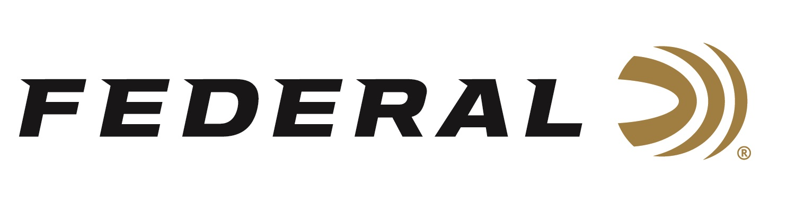

FOR IMMEDIATE RELEASE

**Federal Ammunition Showcases Its All-New 7mm Backcountry**

**Hunting Cartridge at the 2025 SHOT Show**

**ANOKA, Minnesota – January 21, 2025 –** Federal Ammunition recently launched an all-new centerfire rifle hunting cartridge, the 7mm Backcountry. This high-performance, all-range cartridge, with its innovative Peak Alloy case technology, rewrites the rules for modern ammunition. This entirely new cartridge will be showcased at the 2025 SHOT Show, January 21–24, at the Venetian Expo and Caesars Forum in Las Vegas, Nevada. Attendees are encouraged to stop by Booth No. 11838 for a first-hand look at the 7mm Backcountry and other new products.

7mm Backcountry provides superior ballistics and terminal performance through compact, shorter-barreled suppressed rifles, producing 3,000 fps velocities with 170-grain bullets through 20-inch barrels. The cartridge achieves all of this through the patented Peak Alloy case. The next-generation, one-piece case design of an advanced, high-strength alloy allows higher velocities over modern brass case ammunition.

Learn more at [Backcountry | Federal Premium](https://www.federalpremium.com/backcountry.html).

Federal’s all-new 7mm Backcountry cartridge is dimensionally smaller than its closest brass-case counterparts, enabling it to achieve its ballistic advantages through smaller rifles and with an extra round in the magazine of most platforms.

All five of Federal’s 7mm Backcountry loads come in 20-count boxes and have velocity data tables for both 24- and 20-inch barrels on the packaging. This caters to modern hunters looking for high-performance ammunition for shorter rifle barrels to accommodate hunting with suppressors.

**Part No. / Description / MSRP**

P7BCTA1 / 7mm Backcountry 155 gr Terminal Ascent, 3,150 - 3,300 fps / $78.99

P7BCTA3 / 7mm Backcountry 170 gr Terminal Ascent, 3,000 - 3,150 fps / $78.99

P7BCEH1 / 7mm Backcountry 195 gr Berger Elite Hunter, 2,850 - 3,000 fps / $80.99

P7BCLRX1 / 7mm Backcountry 168 gr Barnes LRX, 3,000 - 3,150 fps / $81.99

F7BCTFS2 / 7mm Backcountry 175 gr Fusion Tipped, 2,975 - 3,125 fps / $62.99

*\*Velocities shown are for 20- and 24-inch test barrels.*

Federal Ammunition products can be found at dealers nationwide and online. For more information on all products from Federal, visit [www.federalpremium.com](http://www.federalpremium.com).

Sign up to receive exclusive access to online promotions and news via email by visiting [Federal Ammunition - Sign Up](https://fa.attn.tv/p/F7i/landing-page).

**Press Release Contact:** JJ Reich

Senior Manager – Press Relations

E-mail: media@tkghunt.com

**About Federal Ammunition**

Federal, headquartered in Anoka, MN, is an ammunition brand of The Kinetic Group, owned by CSG, a globally diversified industrial group based in Prague (Czech Republic). From humble beginnings nestled among the lakes and woods of Minnesota, Federal Ammunition has evolved into one of the world's largest producers of sporting ammunition. In 1922, founding President Charles L. Horn paved the way for our success. Today, Federal carries on Horn's vision for quality products and services with the next generation of outdoorsmen and women. We maintain our position as experts in the science of ammunition production. Every day, Federal manufactures products to enhance our customers' shooting experience while partnering with the conservation organizations that protect and support our outdoor heritage. Federal offers thousands of options in our Federal Premium® and standard Federal® lines, which is what makes it the most complete ammunition company in the business and helps it provide customers with a choice no matter what the pursuit.