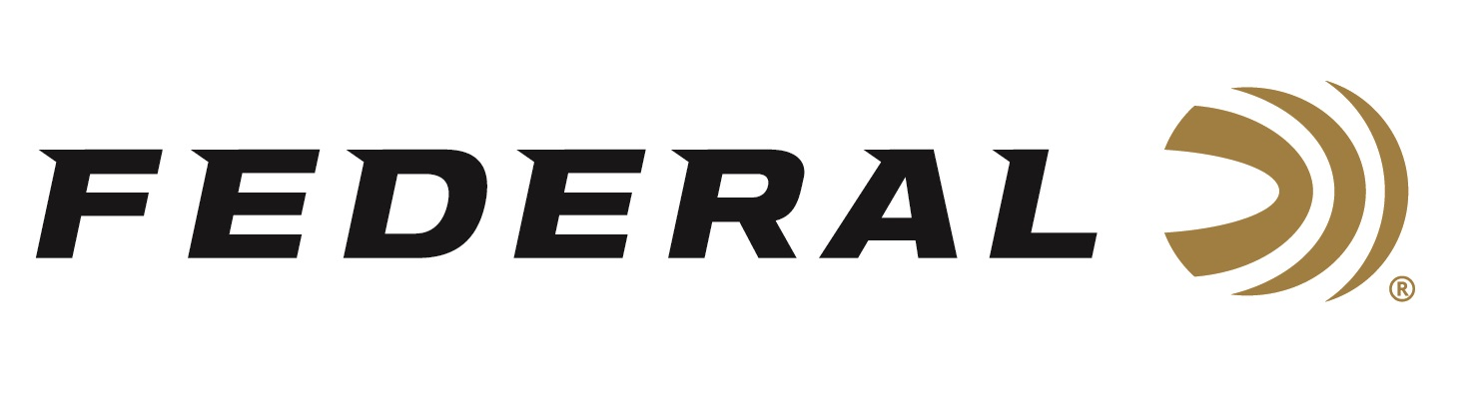

FOR IMMEDIATE RELEASE

**Federal Ammunition Announces Its All-New Master Class Sporting Clay Shotshell Product Line**

**ANOKA, Minnesota – January 15, 2025 –** Federal Ammunition announces an all-new shotshell product line: Federal Master Class. This competition-level sporting clay load features a customized Podium wad that extracts peak performance from utilizing Federal’s straight-wall hull, reliable primers, high-antimony lead shot, and select propellant. This product line will be offered in six 12-gauge loads.

“Master Class gives shooters competitively priced loads with top-quality internal components needed to break the most challenging targets in sporting clays and FITASC,” said Federal’s Shotshell Product Line Manager Josh Vickers. “From the unique and attractive blue hull to a new shot sorting process utilized in its loading, this new product line is built to exceed the expectations of all Sporting Clay shooters.”

Master Class features two components—also used in Federal’s Premium products—including a one-piece Podium wad and high-antimony lead shot that balances hardness and density. It's constructed with a straight-wall hull, inserted plastic base wad, striated tube, and brass-plated steelhead for optimum performance.

Master Class offers a much better option than standard target loads for those who compete in Sporting Clays. It features high-quality components in an ultra-reliable two-piece straight wall hull design. It’s offered in the most popular payloads and velocities for modern Sporting Clays competitions.

Master Class is packaged in 25-count boxes and loaded in six 12-gauge options. It complements Federal’s recently launched Premium High Overall All lineup, which features a one-piece tapered hull and solid brass head for those looking to maximize reloadability.

**PART NO. / DESCRIPTION / MSRP**

MC12H1 7.5 / 12 gauge, 7.5 shot, 2-3/4 inch, 1-ounce, 3-dram, 1,250 fps / $15.99

MC12H1 8 / 12 gauge, 8 shot, 2-3/4 inch, 1-ounce, 3-dram, 1,250 fps / $15.99

MC12HC 7.5 / 12 gauge, 7.5 shot, 2-3/4 inch, 1-1/8 ounce, HDCP, 1,235 fps / $15.99

MC12HC 8 / 12 gauge, 8 shot, 2-3/4 inch, 1-1/8 ounce, HDCP, 1,235 fps / $15.99

MC12HC1 7.5 / 12 gauge, 7.5 shot, 2-3/4 inch, 1-ounce, 3-1/4-dram, 1,300 fps / $15.99

MC12HC1 8 / 12 gauge, 8 shot, 2-3/4 inch, 1-ounce, 3-1/4-dram, 1,300 fps / $15.99

These new products will be showcased and on display at the 2025 SHOT Show, January 21–24 at the Venetian Expo and Caesars Forum in Las Vegas, Nevada. Attendees of the show are encouraged to stop by Booth No. 11838 for a first-hand look at these new products and more.

Information about the 2025 new products can be found on Federal’s brand website soon after the SHOT Show. Sign up to receive exclusive access to online promotions and news via email by visiting [Federal Ammunition - Sign Up](https://fa.attn.tv/p/F7i/landing-page).

Federal Ammunition products can be found at dealers nationwide and online. For more information on all products from Federal, visit [www.federalpremium.com](http://www.federalpremium.com).

**Press Release Contact:** JJ Reich

Senior Manager – Press Relations

E-mail: media@tkghunt.com

**About Federal Ammunition**

Federal, headquartered in Anoka, MN, is an ammunition brand of The Kinetic Group, owned by CSG, a globally diversified industrial group based in Prague (Czech Republic). From humble beginnings nestled among the lakes and woods of Minnesota, Federal Ammunition has evolved into one of the world's largest producers of sporting ammunition. In 1922, founding President Charles L. Horn paved the way for our success. Today, Federal carries on Horn's vision for quality products and services with the next generation of outdoorsmen and women. We maintain our position as experts in the science of ammunition production. Every day, Federal manufactures products to enhance our customers' shooting experience while partnering with the conservation organizations that protect and support our outdoor heritage. Federal offers thousands of options in our Federal Premium® and standard Federal® lines, which is what makes it the most complete ammunition company in the business and helps it provide customers with a choice no matter what the pursuit.