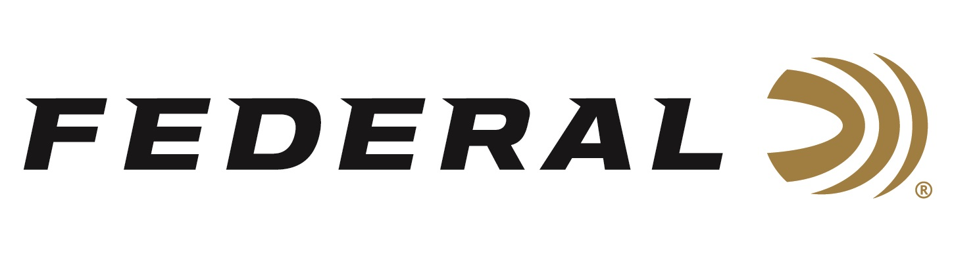

FOR IMMEDIATE RELEASE

**Federal Ammunition Announced Its All-New Upland Paper Shotshell Product Line**

**ANOKA, Minnesota – February 5, 2025 –** Federal Ammunition launches an all-new shotshell product line: Federal Premium Upland Paper. These modern game loads feature classic paper hulls and deliver reliable, accurate performance.

“Shooting the Federal Gold Medal paper load is unlike any other competition load I’ve ever used,” said sponsored shooter Vincent Hancock, four-time Olympic champion. “The consistency, feel, and, of course, the smell is second to none. I can’t wait to use this new high-quality paper-hull load in the field on my next upland hunt!”

Features and benefits include Federal waxed-paper hulls, extra-hard, copper-plated shot for uniform patterns and deeper penetration, select wad design that produces better, more consistent patterns, high-quality propellant and primer for efficient ignition, and more. Federal Premium Upland Paper is packaged in 25-count boxes and loaded in six 2-3/4-inch 12- and 20-gauge options in shot sizes 4, 5, and 6.

“Upland hunters can now experience the nostalgic look, feel, and even smell of classic upland shotshells without losing the benefits of modern performance with this new product line,” said Federal’s Shotshell Product Line Manager Josh Vickers. “Upland Paper is ideal for pheasants, grouse, quail, and small game,” The loads’ exclusive waxed-paper hull holds a hard-hitting payload of extra-hard copper-plated lead shot, as well as a wad column that extracts peak performance with these classic components.”

The all-new product line was recently showcased at the 2025 SHOT Show, held January 21–24 at the Venetian Expo and Caesars Forum in Las Vegas, Nevada.

Information about the 2025 new products can be found on Federal’s website at [New Products | Federal Premium](https://www.federalpremium.com/this-is-federal/new-products.html). Sign up to receive exclusive access to online promotions and news via email by visiting [Federal Ammunition - Sign Up](https://fa.attn.tv/p/F7i/landing-page).

Federal Ammunition products are available at dealers nationwide and online. For more information on all Federal products, visit [www.federalpremium.com](http://www.federalpremium.com).

**Press Release Contact:** JJ Reich

Senior Manager – Press Relations

E-mail: media@tkghunt.com

**About Federal Ammunition**

Federal, headquartered in Anoka, MN, is an ammunition brand of The Kinetic Group, owned by CSG, a globally diversified industrial group based in Prague (Czech Republic). From humble beginnings nestled among the lakes and woods of Minnesota, Federal Ammunition has evolved into one of the world's largest producers of sporting ammunition. In 1922, founding President Charles L. Horn paved the way for our success. Today, Federal carries on Horn's vision for quality products and services with the next generation of outdoorsmen and women. We maintain our position as experts in the science of ammunition production. Every day, Federal manufactures products to enhance our customers' shooting experience while partnering with the conservation organizations that protect and support our outdoor heritage. Federal offers thousands of options in our Federal Premium® and standard Federal® lines, which is what makes it the most complete ammunition company in the business and helps it provide customers with a choice no matter what the pursuit.