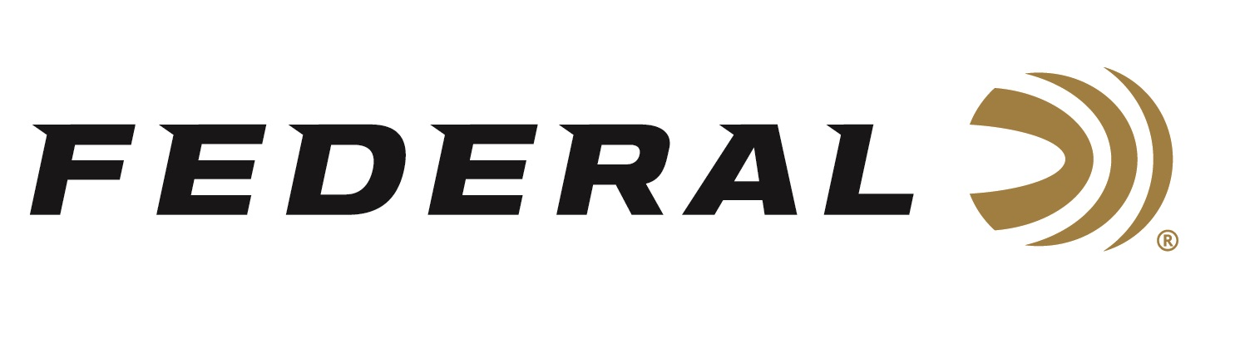

FOR IMMEDIATE RELEASE

**Federal’s 16-Gauge Black Cloud Waterfowl Loads Now Shipping**

**ANOKA, Minnesota – August 14, 2025** – Federal Ammunition has expanded its industry-leading Premium® Black Cloud lineup with new 16-gauge 2-shot and 4-shot waterfowl loads. These loads bring the unmatched performance of Black Cloud FS Steel to 16-gauge shotguns, delivering devastating patterns and lethal energy for waterfowl hunters. These new 16-gauge loads are now shipping to retailers nationwide.

[Black Cloud](https://www.federalpremium.com/shotshell/black-cloud/?prefn1=gauge&prefv1=16%20Gauge)

"16-gauge shotgun enthusiasts can now experience the same cutting-edge technology and performance that Black Cloud is known for." said Josh Vickers, Federal Ammunition Shotshell Product Manager. “Hunters can take full advantage of Black Cloud’s proven technology, delivering tighter patterns and greater downrange effectiveness for waterfowl hunting in yet another great sub-gauge option.”

Black Cloud FS Steel features the rear-deploying FLITECONTROL FLEX wad, which allows for optimal payload separation at the perfect moment, ensuring dense, deadly patterns at extended ranges. Each shell is loaded with a precision-engineered mix of 40% FLITESTOPPER steel pellets and 60% Premium steel pellets, creating larger wound channels and increasing lethality. The high-performance primer and clean-burning, temperature-stable propellant significantly reduces barrel residue. A plated head inhibits corrosion, and a sealed crimp protects against moisture in extreme hunting conditions.

The new 16-gauge Black Cloud FS Steel loads are available in 2-shot and 4-shot, ensuring waterfowl hunters have ideal options for any situation. They join an extensive lineup of 12, 20, and 28-gauge options, providing hunters with a full range of gauge choices to match their shooting preferences and hunting conditions.

**Part No. / Description / MSRP**PWBX167 2 / 16 Gauge, No. 2 shot, 2-3/4-inch, 7/8-ounce, 1,350 fps / $40.99  
PWBX209 4 / 16 Gauge, No. 4 shot, 2-3/4-inch, 7/8-ounce, 1,350 fps / $40.99

Federal Ammunition products are available at dealers nationwide and online. For more information on all Federal products and to sign up to receive notifications about new product availability, rebate promotions, and other brand news via email, visit [www.federalpremium.com](http://www.federalpremium.com).

**Press Release Contact:** JJ Reich  
Senior Manager – Press Relations  
E-mail: [media@tkghunt.com](mailto:media@tkghunt.com)

**About Federal Ammunition**

Federal, headquartered in Anoka, MN, is an ammunition brand of The Kinetic Group, owned by CSG, a globally diversified industrial group based in Prague, Czech Republic. Since 1922, Federal has been a leader in ammunition innovation, delivering high-quality sporting and hunting products to shooters worldwide. With a commitment to conservation and the outdoor community, Federal continues to manufacture industry-leading ammunition that enhances the shooting experience while supporting outdoor traditions.