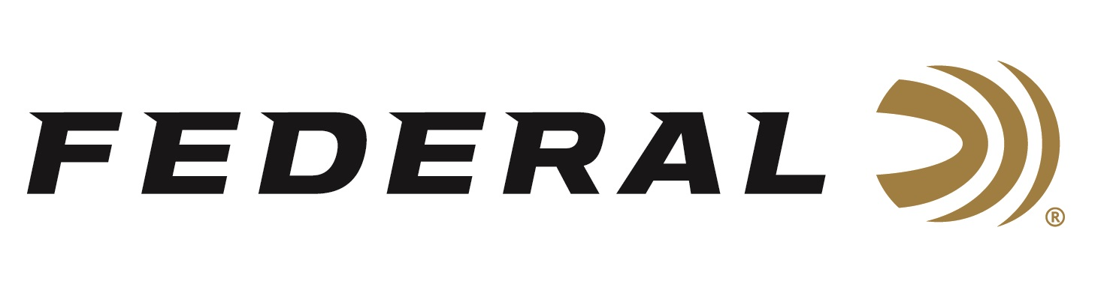

FOR IMMEDIATE RELEASE

**Federal’s Break Clays & Save Shotshell Rebate Program is Underway**

**ANOKA, Minnesota – April 3, 2025 –** Federal Ammunition's Break Clays & Save rebate for Federal Premium High Over All (HOA) 12- or 20-gauge ammunition recently launched, and the promotion will run until June 30, 2025. Shooters can now buy some of Federal’s best clay target loads and get up to $50 back.

“With this great promotion, target shooters can gear up for both spring and summer while also putting a few bucks back in their pocket,” said Federal's Senior Manager of Trade Marketing Bart Biedinger. “This program began April 1 and will continue through June, making it a great time to take advantage of this cost-saving promotion.”

To take advantage of this rebate, customers must purchase at least 10 boxes of 12- or 20-gauge Federal Premium High Over All shotshells to get a rebate of $1.00 per box.

Valid purchases must be made from April 1 through June 30, 2025. The deadline for submission of this rebate offer is July 31, 2025. A minimum purchase of 10 boxes is required, with a maximum rebate of $50 per person or household.

All trap, skeet, and sporting clay shooters can enjoy the highly engineered benefits of HOA’s ultimate clay-busting design, which leaves a trail of shattered targets in its wake and more reloads per shell. It’s hard lead payload produces the most consistent patterns, while the solid brass head and hull design make reloading easier than ever. It's the ultimate competition load for the world's best shooters.

For complete details on rebates, visit: <https://www.federalpremium.com/this-is-federal/rebates-and-promotions.html>.

Federal Ammunition products are available at dealers nationwide and online. For more information on all Federal products, visit [www.federalpremium.com](http://www.federalpremium.com).

**Press Release Contact:** JJ Reich

Senior Manager – Press Relations

E-mail: media@tkghunt.com

**About Federal Ammunition**

Federal, headquartered in Anoka, MN, is an ammunition brand of The Kinetic Group, owned by CSG, a globally diversified industrial group based in Prague (Czech Republic). From humble beginnings nestled among the lakes and woods of Minnesota, Federal Ammunition has evolved into one of the world's largest producers of sporting ammunition. In 1922, founding President Charles L. Horn paved the way for our success. Today, Federal carries on Horn's vision for quality products and services with the next generation of outdoorsmen and women. We maintain our position as experts in the science of ammunition production. Every day, Federal manufactures products to enhance our customers' shooting experience while partnering with the conservation organizations that protect and support our outdoor heritage. Federal offers thousands of options in our Federal Premium® and standard Federal® lines, which is what makes it the most complete ammunition company in the business and helps it provide customers with a choice no matter what the pursuit.