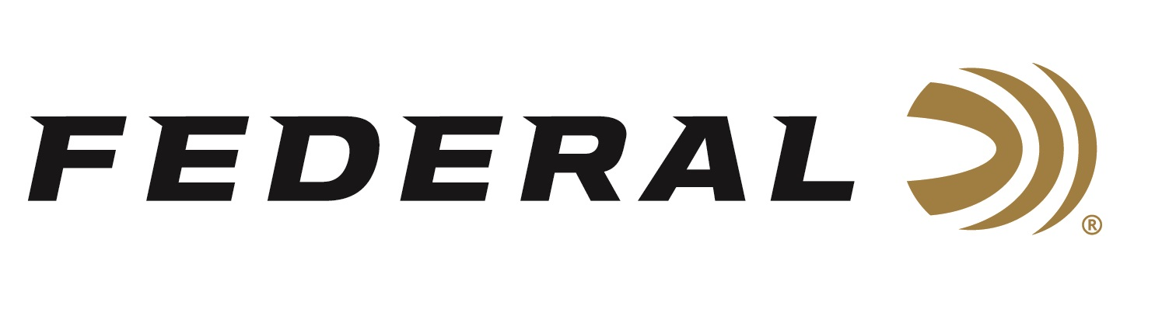

FOR IMMEDIATE RELEASE

**Federal Will Release New Centerfire Rifle Ammo Options in 2025**

**ANOKA, Minnesota – January 13, 2025 –** Federal Ammunition proudly announces several new centerfire rifle ammunition options for 2025. Above and beyond Federal’s launch of its all-new hunting cartridge, the 7mm Backcountry, additional new ammunition loadings will be added to the Barnes LRX, Gold Medal Berger, and Terminal Ascent product lines.

Barnes LRX is an all-new product line loaded in the following cartridges: 7mm Backcountry, 280 Ackley Improved, 300 Win. Mag., 308 Win., 6.5 Creedmoor, 6.5 PRC, 7 PRC, and 7mm Rem. Mag. Barnes LRX copper leans on its high ballistic coefficient to maximize range and power, then closes the deal with a unique nose cavity that expands reliably and devastatingly to take big game at all practical distances.

Gold Medal Berger will now be offered in 6mm ARC: These loads feature an advanced boat-tail bullet with a high ballistic coefficient to provide the flattest trajectories, less wind drift, and surgical long-range accuracy.

Terminal Ascent will now be offered in 7mm Backcountry, 6.5 PRC, 300 RUM, and 300 Win. Mag.: The Federal Premium Terminal Ascent's bonded bullet construction penetrates deep on close targets, while the patented Slipstream polymer tip initiates expansion at extreme long range.

Federal’s all-new long-action 7mm Backcountry hunting cartridge raises the bar for what a non-magnum, centerfire rifle hunting load can achieve. The patented Peak Alloy one-piece, high-strength case boosts the new Federal-designed 7mm Backcountry cartridge, which provides magnum performance in a standard bolt face rifle. Through 20-inch barrels and with 170-grain bullets, it can achieve 3,000 feet per second. Learn more at [Backcountry | Federal Premium](https://www.federalpremium.com/backcountry.html).

These all-new products will be showcased and on display at the 2025 SHOT Show, January 21–24 at the Venetian Expo and Caesars Forum in Las Vegas, Nevada. Attendees of the show are encouraged to stop by Booth No. 11838 for a first-hand look at these new products and more.

Information about the 2025 new products can be found on Federal’s brand website soon after the SHOT Show. Sign up to receive exclusive access to online promotions and news via email by visiting [Federal Ammunition - Sign Up](https://fa.attn.tv/p/F7i/landing-page).

Federal Ammunition products can be found at dealers nationwide and online. For more information on all products from Federal, visit [www.federalpremium.com](http://www.federalpremium.com).

**Press Release Contact:** JJ Reich

Senior Manager – Press Relations

E-mail: media@tkghunt.com

**About Federal Ammunition**

Federal, headquartered in Anoka, MN, is an ammunition brand of The Kinetic Group, owned by CSG, a globally diversified industrial group based in Prague (Czech Republic). From humble beginnings nestled among the lakes and woods of Minnesota, Federal Ammunition has evolved into one of the world's largest producers of sporting ammunition. In 1922, founding President Charles L. Horn paved the way for our success. Today, Federal carries on Horn's vision for quality products and services with the next generation of outdoorsmen and women. We maintain our position as experts in the science of ammunition production. Every day, Federal manufactures products to enhance our customers' shooting experience while partnering with the conservation organizations that protect and support our outdoor heritage. Federal offers thousands of options in our Federal Premium® and standard Federal® lines, which is what makes it the most complete ammunition company in the business and helps it provide customers with a choice no matter what the pursuit.