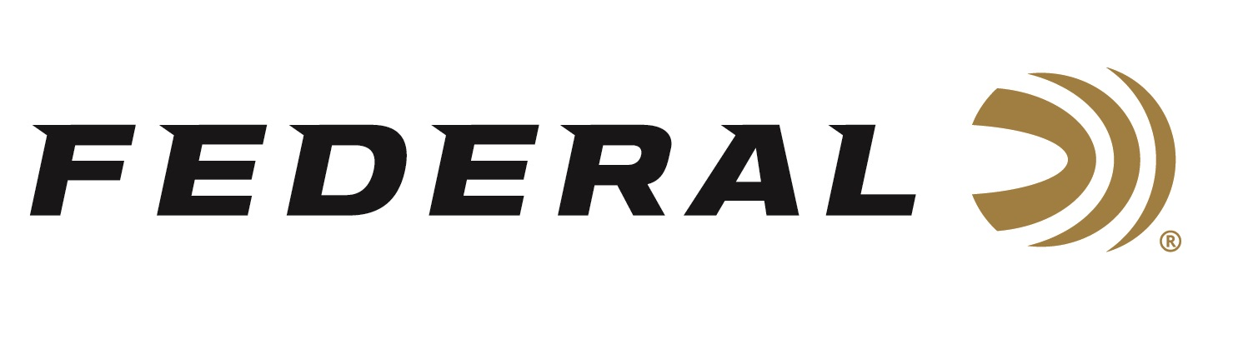

FOR IMMEDIATE RELEASE

**Federal Ammunition Fast Savings Rebate Program Going Strong**

**ANOKA, Minnesota – February 12, 2025 –** Federal Ammunition's Fast Savings promotion for winter and springtime waterfowl hunters is underway and will run until March 10, 2025.

“With this great promotion, waterfowl hunters can keep filling game bags while also putting a few bucks back in their pocket,” said Federal's Senior Manager of Trade Marketing Bart Biedinger. “This program started in early January but goes throughout March, so it’s not too late to participate in these cost-saving promotions for any upcoming snow goose hunt.”

Details of the Federal’s Fast Savings Rebate include buying at least two (2) boxes of Federal Speed-Shok, Speed-Shok Snow Goose, or Speed-Shok Sea Duck shotshell ammunition to get a $5.00 per box rebate. The offer includes Federal Hi-Power shotshell ammunition. 100-count bulk pack is equal to four (4) standard boxes. A minimum purchase of two (2) boxes or one (1) 100-count bulk pack is required. The maximum rebate is $200 per person or household. Valid for purchases made January 9 through March 10, 2025. The deadline for online submission is March 31, 2025.

Federal Speed-Shok’s high-performance primer and fast-burning powder dramatically reduce residue while its optimized velocities knock birds out of the sky. It’s available in various product types, gauges, velocities, and shot sizes.

For complete details on rebates, visit: <https://www.federalpremium.com/this-is-federal/rebates-and-promotions.html>.

Federal Ammunition products are available at dealers nationwide and online. For more information on all Federal products, visit [www.federalpremium.com](http://www.federalpremium.com).

**Press Release Contact:** JJ Reich

Senior Manager – Press Relations

E-mail: media@tkghunt.com

**About Federal Ammunition**

Federal, headquartered in Anoka, MN, is an ammunition brand of The Kinetic Group, owned by CSG, a globally diversified industrial group based in Prague (Czech Republic). From humble beginnings nestled among the lakes and woods of Minnesota, Federal Ammunition has evolved into one of the world's largest producers of sporting ammunition. In 1922, founding President Charles L. Horn paved the way for our success. Today, Federal carries on Horn's vision for quality products and services with the next generation of outdoorsmen and women. We maintain our position as experts in the science of ammunition production. Every day, Federal manufactures products to enhance our customers' shooting experience while partnering with the conservation organizations that protect and support our outdoor heritage. Federal offers thousands of options in our Federal Premium® and standard Federal® lines, which is what makes it the most complete ammunition company in the business and helps it provide customers with a choice no matter what the pursuit.