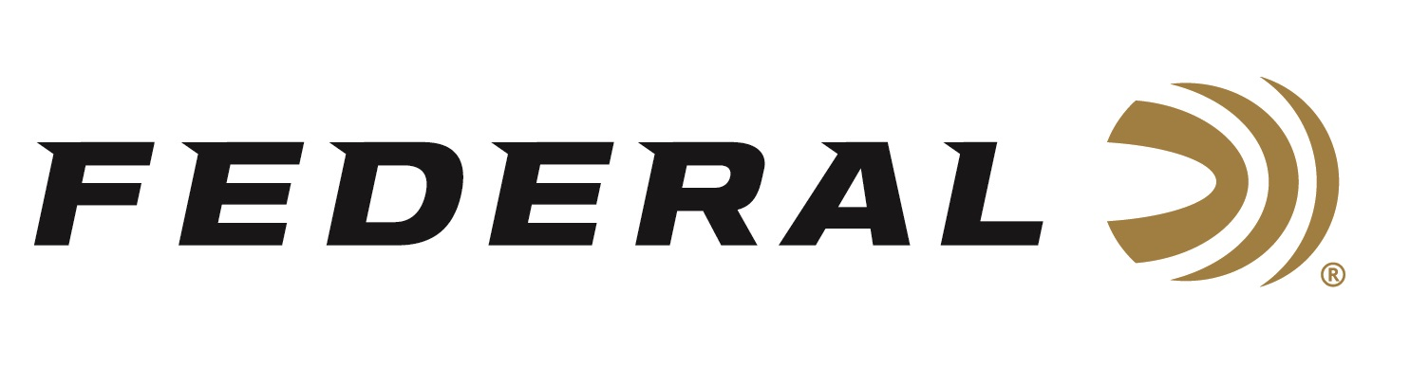

FOR IMMEDIATE RELEASE

**Louisiana Becomes 26th State to Legalize FireStick Technology**

**ANOKA, Minnesota – May 13, 2025 –** Hunters in Louisiana will be able to utilize Federal’s innovative FireStick technology during 2025 fall hunting seasons after the Louisiana Wildlife and Fisheries Commission recently approved regulation changes. The Congressional Sportsmen’s Foundation (CSF) had urged the state to amend its definition of what constitutes a legal firearm during the primitive firearms seasons, and the Commission approved the language updates at their May meeting.

“Federal Ammunition applauds this move by the Louisiana Wildlife and Fisheries Commission and its recognition of modern systems that promote safety, reliability, and increased opportunities,” said Vice President of Marketing Jason Nash. “Federal also appreciates the efforts of our industry partners, including CSF, and their advocacy for the legalization of technology advancements like FireStick and the firearms companies building guns supporting the system,” says Nash.

“CSF thanks the Louisiana Wildlife and Fisheries Commission for working with us to update their regulations so innovations like Federal’s FireStick are legal and available to sportsmen and women that want to embrace technology advancements,” said Mark Lance, Assistant Manager for Southeastern States. “Working on behalf of our industry partners to effect change and advance opportunities is core to our mission to inform, influence, and defend policies that protect and promote outdoor traditions,” continued Lance.

Louisiana is now the 26th state to recognize innovation in muzzle-loading technology by redefining its definition of a primitive firearm. The FireStick is a polymer capsule precisely filled with an exact charge of Hodgdon Triple 8, an ultra-clean black powder substitute. In other words, it’s a premeasured self-contained powder charge. The primary benefit of the FireStick is best-in-class safety. It allows safe, easy removal of the unfired charge from the breech. The benefits of overall better shot consistency for improved accuracy and ease of use follow close behind.

Federal Ammunition products are available at dealers nationwide and online. For more information on all Federal products and to sign up for notifications about new product availability, rebate promotions, and other brand news via email, visit [www.federalpremium.com](http://www.federalpremium.com).

**Press Release Contact:** JJ Reich

Senior Manager – Press Relations

E-mail: media@tkghunt.com

**About Federal Ammunition**

Federal, headquartered in Anoka, MN, is an ammunition brand of The Kinetic Group, owned by CSG, a globally diversified industrial group based in Prague (Czech Republic). From humble beginnings nestled among the lakes and woods of Minnesota, Federal Ammunition has evolved into one of the world's largest producers of sporting ammunition. In 1922, founding President Charles L. Horn paved the way for our success. Today, Federal carries on Horn's vision for quality products and services with the next generation of outdoorsmen and women. We maintain our position as experts in the science of ammunition production. Every day, Federal manufactures products to enhance our customers' shooting experience while partnering with the conservation organizations that protect and support our outdoor heritage. Federal offers thousands of options in our Federal Premium® and standard Federal® lines, which is what makes it the most complete ammunition company in the business and helps it provide customers with a choice no matter what the pursuit.