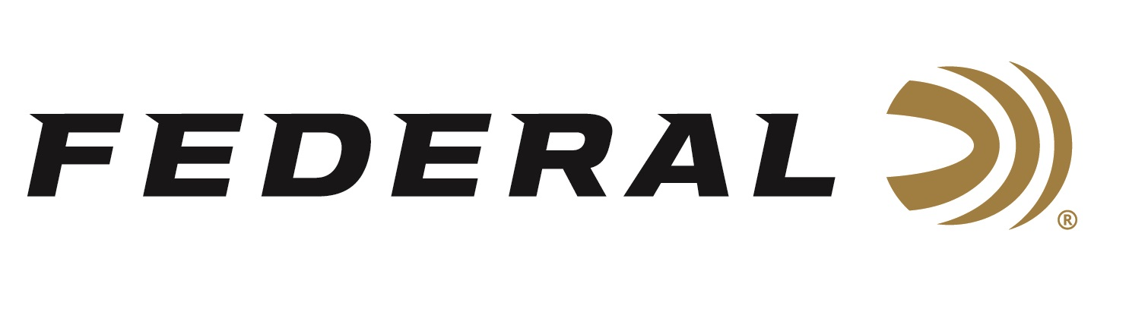

FOR IMMEDIATE RELEASE

**Federal’s New 20-Gauge Gold Medal Paper Shotshells Now Shipping**

**ANOKA, Minnesota – July 31, 2025** – Federal Ammunition recently added two 20-gauge options to its Premium® Gold Medal Paper shotshell product line. These new loads feature the one-piece Podium wad, delivering improved pattern consistency and performance for serious clay target shooters. Known for their classic paper hull design and trusted reliability, the new 20-gauge shotshells are sure to impress. These new products are currently being delivered to retailers nationwide.

[Gold Medal Paper](https://www.federalpremium.com/shotshell/gold-medal-paper/?prefn1=gauge&prefv1=20%20Gauge)

"Gold Medal Paper shotshells continue to be a favored choice for competitive clay shooters who demand the best in consistency, reliability, and feel," said Josh Vickers, Federal Ammunition Shotshell Product Manager. "With the addition of our one-piece Podium wad in 20-gauge loads, we've improved pattern uniformity and reduced felt recoil—giving shooters an even greater edge in competition."

The exclusive Federal Premium paper hull provides the traditional, nostalgic look and feel that dedicated competitors appreciate, while the high antimony lead is precision-engineered for the perfect balance of hardness and density, ensuring even patterns and maximum downrange power. The brass head enhances reliability by ensuring smooth cycling and consistent extraction, even during high-volume shooting sessions.

The 20-gauge Federal Gold Medal Paper shotshells join the lineup of 11 distinct 12-gauge options. The 12-gauge product line features the Podium wad to minimize felt recoil and enhance pattern density. The 20-gauge loads will be available in 7.5 and 8 shot sizes in 2 ¾-inch shotshells, featuring 7/8 ounces of shot and a velocity of 1,250 fps.

**Part No. / Description / MSRP**GMT224 7.5 / 20 Gauge, No. 7.5 shot, 2-3/4-inch, 7/8-ounce, 1,250 fps / $21.99  
GMT224 8 / 20 Gauge, No. 8 shot, 2-3/4-inch, 7/8-ounce, 1,250 fps / $21.99

Federal Ammunition products are available at dealers nationwide and online. For more information on all Federal products and to sign up for new product notifications, rebate promotions, and brand news, visit [www.federalpremium.com](http://www.federalpremium.com).

**Press Release Contact:** JJ Reich  
Senior Manager – Press Relations  
E-mail: [media@tkghunt.com](mailto:media@tkghunt.com)

**About Federal Ammunition**

Federal, headquartered in Anoka, MN, is an ammunition brand of The Kinetic Group, owned by CSG, a globally diversified industrial group based in Prague, Czech Republic. Since 1922, Federal has been a leader in ammunition innovation, delivering high-quality sporting and hunting products to shooters worldwide. With a commitment to conservation and the outdoor community, Federal continues to manufacture industry-leading ammunition that enhances the shooting experience while supporting outdoor traditions.