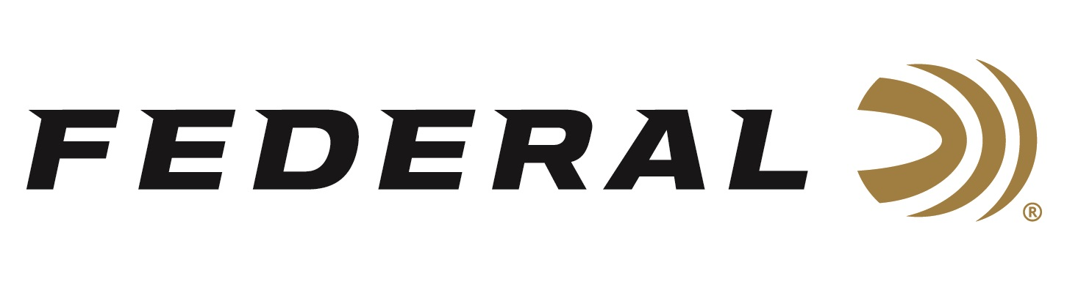

FOR IMMEDIATE RELEASE

**Federal Will Release Many New Handgun Ammo Options in 2025**

**ANOKA, Minnesota – January 10, 2025 –** Federal Ammunition proudly announces new handgun ammunition options for 2025. Several new options will be added to the Federal Premium HST, Federal Premium Hydra-Shok Deep, Federal American Eagle, and Federal Power-Shok Handgun product lines.

HST’s new 44 Rem Mag. load has been optimized for personal defense. It provides more energy than 10mm Auto and 357 Magnum with a larger diameter, 230-grain projectile. However, it has better control and less overpenetration than a full-magnum 44 Rem. Mag. hunting load.

Hydra-Shok Deep will now be offered in 45 Colt and 32 H&R. The modern defense projectiles in these new loads are optimized to offer the best terminal performance for these specific cartridges, with controlled expansion that perfectly balances expansion size and penetration depth.

American Eagle will now be offered in 32 H&R. Hit your target and train harder with this proven line. It provides performance similar to self-defense and competition loads for a familiar feel and realistic practice.

Power-Shok Handgun will now be offered in 10mm Auto. This short-barrel performance goes the distance. Handgun hunters get the power and accuracy they need with a jacketed hollow-point bullet suited to a variety of medium and big game.

These all-new products will be showcased and on display at the 2025 SHOT Show, January 21–24 at the Venetian Expo and Caesars Forum in Las Vegas, Nevada. Attendees of the show are encouraged to stop by Booth No. 11838 for a first-hand look at these new products and more.

Information about the 2025 new products can be found on Federal’s brand website soon after the SHOT Show. Sign up to receive exclusive access to online promotions and news via email by visiting [Federal Ammunition - Sign Up](https://fa.attn.tv/p/F7i/landing-page).

Federal Ammunition products can be found at dealers nationwide and online. For more information on all products from Federal, visit [www.federalpremium.com](http://www.federalpremium.com).

**Press Release Contact:** JJ Reich

Senior Manager – Press Relations

E-mail: media@tkghunt.com

**About Federal Ammunition**

Federal, headquartered in Anoka, MN, is an ammunition brand of The Kinetic Group, owned by CSG, a globally diversified industrial group based in Prague (Czech Republic). From humble beginnings nestled among the lakes and woods of Minnesota, Federal Ammunition has evolved into one of the world's largest producers of sporting ammunition. In 1922, founding President Charles L. Horn paved the way for our success. Today, Federal carries on Horn's vision for quality products and services with the next generation of outdoorsmen and women. We maintain our position as experts in the science of ammunition production. Every day, Federal manufactures products to enhance our customers' shooting experience while partnering with the conservation organizations that protect and support our outdoor heritage. Federal offers thousands of options in our Federal Premium® and standard Federal® lines, which is what makes it the most complete ammunition company in the business and helps it provide customers with a choice no matter what the pursuit.