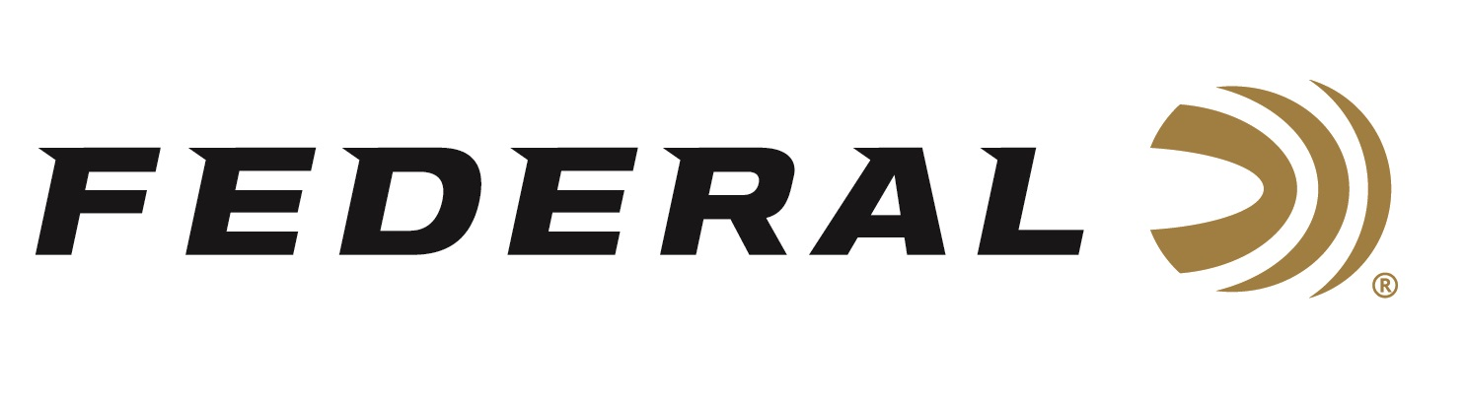

FOR IMMEDIATE RELEASE

**Federal’s Hit the Range Rifle Rebate Program is Underway**

**ANOKA, Minnesota – April 2, 2025 –** Federal Ammunition's Hit the Range rebate for Federal or American Eagle 223 Rem. and 5.56x45mm ammunition recently launched, and the promotion will run until June 30, 2025. Shooters can now buy their favorite training and plinking loads and get up to $200 back.

To take advantage of this rebate, customers must purchase at least 200 rounds of qualifying Federal or American Eagle 223 Rem. or 5.56x45mm full metal jacket (FMJ), full metal jacket boat tail (FMJ BT), Total Metal Jacket (TMJ) or others with manufacturer’s part numbers that begin with AE223 or XM193 to receive a rebate based on the number of rounds purchased.

A minimum purchase of 200 rounds is required, with a maximum rebate of $200 per person or household. Valid purchases must be made from April 1 through June 30, 2025. The deadline for submission of this rebate offer is July 31, 2025.

American Eagle rifle ammunition offers consistent, accurate, affordable range performance. The loads feature quality bullets, reloadable brass cases, and dependable primers. They're available in a wide variety of load, bullet grain weight, and packaging options and are ideal for target and training practice in all rifle platforms.

For complete details on rebates, visit: <https://www.federalpremium.com/this-is-federal/rebates-and-promotions.html>.

Federal Ammunition products are available at dealers nationwide and online. For more information on all Federal products and to sign up to receive notifications about new product availability, rebate promotions, and other brand news via email, visit [www.federalpremium.com](http://www.federalpremium.com).

**Press Release Contact:** JJ Reich

Senior Manager – Press Relations

E-mail: media@tkghunt.com

**About Federal Ammunition**

Federal, headquartered in Anoka, MN, is an ammunition brand of The Kinetic Group, owned by CSG, a globally diversified industrial group based in Prague (Czech Republic). From humble beginnings nestled among the lakes and woods of Minnesota, Federal Ammunition has evolved into one of the world's largest producers of sporting ammunition. In 1922, founding President Charles L. Horn paved the way for our success. Today, Federal carries on Horn's vision for quality products and services with the next generation of outdoorsmen and women. We maintain our position as experts in the science of ammunition production. Every day, Federal manufactures products to enhance our customers' shooting experience while partnering with the conservation organizations that protect and support our outdoor heritage. Federal offers thousands of options in our Federal Premium® and standard Federal® lines, which is what makes it the most complete ammunition company in the business and helps it provide customers with a choice no matter what the pursuit.