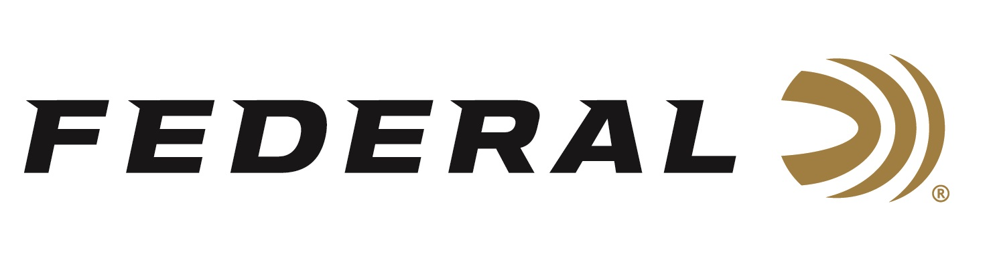

FOR IMMEDIATE RELEASE

**Federal Will** **Release More Than 30 New Shotshell Options in 2025**

**ANOKA, Minnesota – January 9, 2025 –** Federal Ammunition proudly announces many new shotshell ammunition options for 2025. Two all-new ammunition product lines, Master Class and Upland Paper, will be launched in 2025. Additionally, product line extensions will be added to the Black Cloud, Heavyweight TSS, HEVI-Bismuth, Hi-Bird Fiber Wad, Gold Medal Paper, and Ultra Steel lineups.

Master Class will comprise six 2 3/4-inch 12-gauge offerings, 7.5 and 8 shot. This competition-level sporting clay load features a customized Podium wad that extracts peak performance from Federal’s straight-wall hull. Reliable primers, high-antimony lead shot, and select propellant combine to break the most challenging targets.

Upland Paper will comprise six 2 3/4-inch 12- and 20-gauge offerings, 4, 5, and 6 shot. Experience the nostalgic look, feel, and even smell of classic upland shotshells without losing the benefits of modern performance with new Federal Premium Upland Paper.

Black Cloud will now be offered in two 2 3/4-inch 16-gauge offerings, 2 and 4 shot. Black Cloud FS Steel is equipped with the FLITECONTROL FLEX wad to deliver improved pattern density and consistency through both ported and standard waterfowl chokes.

Heavyweight TSS will now be offered in two 28-gauge offerings, 2 3/4-inch and 3-inch, 9 shot. The tungsten-alloy shot material’s 18 g/cc density is 56 percent more than lead, resulting in the highest pellet counts, and the most energy at extreme range.

HEVI-Bismuth will now be offered in seven 2 3/4-inch 16- and 3-inch 28-gauge offerings, 3, 4, and 5 shot. Launched by the FLITECONTROL FLEX wad, 9.6 g/cc HEVI-Bismuth pellets pattern consistently, and their metallic properties make them safe in both modern and classic shotguns.

Hi-Bird Fiber Wad will now be offered in two 2 3/4-inch 12-gauge offerings, 4 and 6 shot. Reduce your impact on high-volume shoots. Hi-Bird Fiber Wad’s cellulose-based over-powder wad construction helps minimize plastic left in the field. It’s perfect for the field or preserve hunting situations.

Gold Medal Paper will now be offered in two 2 3/4-inch 20-gauge offerings, 7.5 and 8 shot. Now available in 20-gauge loads equipped with extra-high-antimony lead shot and the one-piece Podium wad.

Ultra Steel will now be offered in four 3 1/2-inch 10- and 12-gauge offerings, BBB/1, BB/2, and 2/4 shot. Federal Premium Ultra Steel features the rear-opening FLITECONTROL FLEX wad and a zinc-plated steel payload. It is available in a variety of standard payloads and loads that feature two sizes of shot.

These all-new products will be showcased and on display at the 2025 SHOT Show, January 21–24 at the Venetian Expo and Caesars Forum in Las Vegas, Nevada. Attendees of the show are encouraged to stop by Booth No. 11838 for a first-hand look at these new products and more.

Information about the 2025 new products can be found on Federal’s brand website soon after the SHOT Show. Sign up to receive exclusive access to online promotions and news via email by visiting [Federal Ammunition - Sign Up](https://fa.attn.tv/p/F7i/landing-page).

Federal Ammunition products can be found at dealers nationwide and online. For more information on all products from Federal, visit [www.federalpremium.com](http://www.federalpremium.com).

**Press Release Contact:** JJ Reich

Senior Manager – Press Relations

E-mail: media@tkghunt.com

**About Federal Ammunition**

Federal, headquartered in Anoka, MN, is an ammunition brand of The Kinetic Group, owned by CSG, a globally diversified industrial group based in Prague (Czech Republic). From humble beginnings nestled among the lakes and woods of Minnesota, Federal Ammunition has evolved into one of the world's largest producers of sporting ammunition. In 1922, founding President Charles L. Horn paved the way for our success. Today, Federal carries on Horn's vision for quality products and services with the next generation of outdoorsmen and women. We maintain our position as experts in the science of ammunition production. Every day, Federal manufactures products to enhance our customers' shooting experience while partnering with the conservation organizations that protect and support our outdoor heritage. Federal offers thousands of options in our Federal Premium® and standard Federal® lines, which is what makes it the most complete ammunition company in the business and helps it provide customers with a choice no matter what the pursuit.