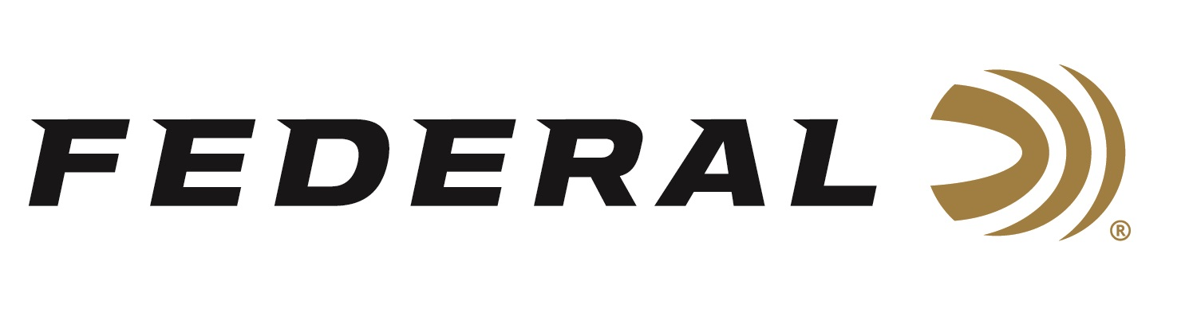

FOR IMMEDIATE RELEASE

**Federal Ammunition Sponsors the 2025 Minnesota State Sporting Clays Championship**

**ANOKA, Minnesota – August 18, 2025 –** Federal Ammunition is proud to be the Presenting Sponsor of the 2025 Minnesota State Sporting Clays Championship. The event will be held at the Hunts Point Gun Club in Pequot Lakes, Minnesota, August 20-24, 2025. Team Federal’s world-champion sporting clays shooter Gregg Wolf will be in attendance and will compete in the event.

“Minnesota is our home state, and we are proud to sponsor this great event, which is just a short trip from our factory,” said Federal’s Vice President of Marketing Jason Nash. “Hardworking people at our factory in Anoka manufacture our ammunition, and it has a worldwide reputation for high quality and reliability that we are certainly very proud of. We are excited to cheer on Gregg Wolf, along with other athletes, as they compete in the state championship, and put our products to great use.”

Federal Ammunition recently launched an all-new shotshell product line: Federal Master Class. This competition-level sporting clay load features a customized Podium wad that extracts peak performance from utilizing Federal’s straight-wall hull, reliable primers, high-antimony lead shot, and select propellant.

Master Class offers a much better option than standard target loads for those who compete in Sporting Clays. It features high-quality components in an ultra-reliable two-piece straight-wall hull design and is offered in the most popular payloads and velocities for modern Sporting Clays competitions.

Learn more at: [Master Class | Federal Ammunition](https://www.federalpremium.com/shotshell/master-class/).

Federal Ammunition products are available at dealers nationwide and online. For more information on all Federal products and to sign up to receive notifications about new product availability, rebate promotions, and other brand news via email, visit [www.federalpremium.com](http://www.federalpremium.com).

**Press Release Contact:** JJ Reich  
Senior Manager – Press Relations  
E-mail: [media@tkghunt.com](mailto:media@tkghunt.com)

**About Federal Ammunition**

Federal, headquartered in Anoka, MN, is an ammunition brand of The Kinetic Group, owned by CSG, a globally diversified industrial group based in Prague, Czech Republic. Since 1922, Federal has been a leader in ammunition innovation, delivering high-quality sporting and hunting products to shooters worldwide. With a commitment to conservation and the outdoor community, Federal continues to manufacture industry-leading ammunition that enhances the shooting experience while supporting outdoor traditions.