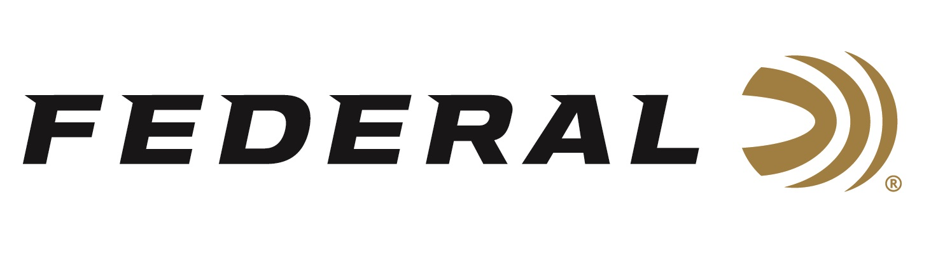

FOR IMMEDIATE RELEASE

**Team Federal’s Stuart Brown Crushes It at the 2025 World Skeet Championships**

**ANOKA, Minnesota – October 9, 2025 –** Federal Ammunition congratulates sponsored shooter Stuart Brown for an outstanding performance at the 2025 World Skeet Championships. The championships were held from September 26 to October 4, 2025, at the National Shooting Complex in San Antonio, Texas. Brown finished on top of the podium in two events and medaled in two others. He was the 12-gauge East Event Champion and the 28-gauge Champion while also earning Runner-Up in both the HAA and Doubles events.

“We congratulate Stuart Brown for his solid performance at this world-class event using our Federal shotshells to break a ton of targets,” said Jason Nash, Vice President of Marketing for Federal. “We make shotshells engineered for the most elite skeet shooters, and we do it well. Our loads produce consistent, hard-hitting patterns that help shooters like Brown reach the podium. In short, we make the ultimate competition loads for the world's best shooters.”

Leading up to the 2025 World Skeet Championships was the Mini-World Competition. Team Federal’s Connor Ball was the 12-gauge Main Event Champion.

Federal Ammunition recently launched an all-new shotshell product line: Federal All-American. These competition-level target loads use a Podium wad that’s customized for straight-wall hulls. The design’s exclusive compression zone cushions the payload at ignition, resulting in better patterns and softer shooting. All-American’s high-antimony lead shot is pushed by quality propellant and primers to crush the most challenging targets in high-level Trap and Skeet shooting.

Learn more at: [All-American | Federal Premium](https://www.federalpremium.com/shotshell/all-american/)

Federal Ammunition products are available at dealers nationwide and online. For more information on all Federal products and to sign up to receive notifications about new product availability, rebate promotions, and other brand news via email, visit [www.federalpremium.com](http://www.federalpremium.com).

**Press Release Contact:** JJ Reich  
Senior Manager – Press Relations  
E-mail: [media@tkghunt.com](mailto:media@tkghunt.com)

**About Federal Ammunition**

Federal, headquartered in Anoka, MN, is an ammunition brand of The Kinetic Group, owned by CSG, a globally diversified industrial group based in Prague, Czech Republic. Since 1922, Federal has been a leader in ammunition innovation, delivering high-quality sporting and hunting products to shooters worldwide. With a commitment to conservation and the outdoor community, Federal continues to manufacture industry-leading ammunition that enhances the shooting experience while supporting outdoor traditions.