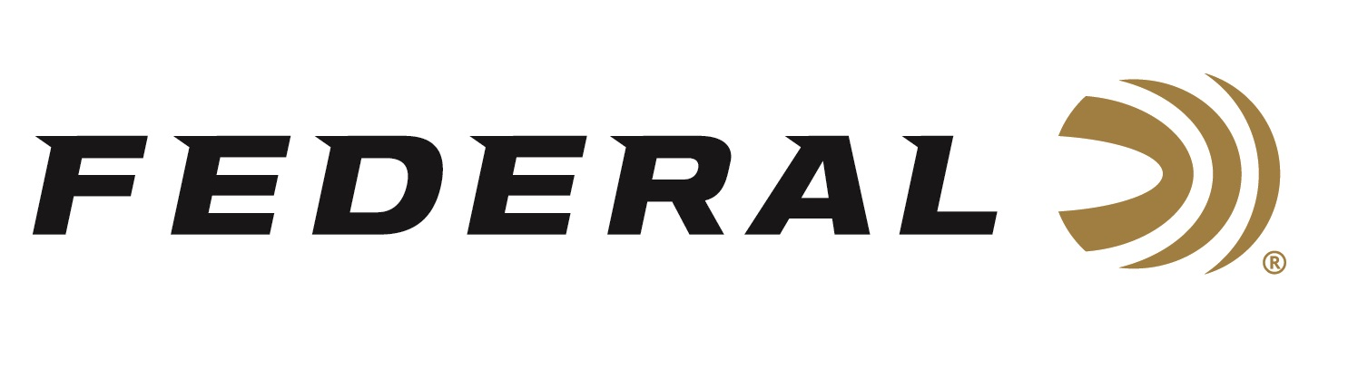

FOR IMMEDIATE RELEASE

**Federal Ammunition Announces Five Fall Rebates on Popular Centerfire Hunting Loads**

**ANOKA, Minnesota** – **August 4, 2025** — Federal Ammunition is giving hunters even more reason to gear up this fall with five limited-time rebate programs covering a wide range of its popular rifle and handgun centerfire hunting ammunition lines. From August 1 through November 30, 2025, customers can earn up to $60 back on eligible purchases through the following Federal rebate promotions:

**Power-Shok Rifle Rebate –** Get up to $60 back when you buy at least two boxes of Federal Power-Shok centerfire rifle ammunition. Qualifying products include Power-Shok and Power-Shok Copper.

**Fusion Deals –** Save up to $60 on purchases of at least two boxes of Federal Fusion centerfire rifle ammunition. Qualifying products include Fusion, Fusion MSR, and Fusion Tipped.

**Premium® Rifle Rebate –** Purchase at least two boxes of select Federal Premium hunting rifle ammunition and receive 20 percent back, up to $60. Qualifying products include Trophy Bonded Tip, Terminal Ascent, Berger Hybrid Hunter, ELD-X, Barnes Barnes TSX, HammerDown, and Trophy Copper.

**Safari Savings –** Get 20 percent back on select Federal Premium Safari centerfire rifle ammunition purchases, up to $60. Qualifying products include Trophy Bonded Bear Claw, Trophy Bonded Sledgehammer Solid, Swift A-Frame, and Woodleigh Hydro Solid.

**Hunting Handgun Rebate –** Earn up to $60 back when you buy at least two boxes of select Federal centerfire handgun hunting ammunition. Qualifying products include Trophy Bonded Bear Claw, Swift A-Frame, Solid Core, HammerDown, Power-Shok, Fusion, and Barnes Expander.

“With these five strong rebate programs, we’re helping hunters prepare with some of our most trusted rifle and handgun loads,” said Federal’s Senior Manager of Trade Marketing, Bart Biedinger. “Whether it’s deer season, safari adventure, or handgun hunting, this is a great time to stock up and save.”

Each rebate offers 20 percent back on qualifying purchases, with a maximum of $60 per person or household. Valid purchase dates span from August 1 through November 30, 2025, and rebate submissions must be received by December 31, 2025. Additional terms, conditions and exclusions apply. For complete rebate details, visit: <https://www.federalpremium.com/this-is-federal/rebates-and-promotions.html>

Federal Ammunition products are available at dealers nationwide and online. For more information on all Federal products and to sign up for notifications about new product availability, rebate promotions, and other brand news via email, visit [www.federalpremium.com](http://www.federalpremium.com).

**Press Release Contact:** JJ Reich  
Senior Manager – Press Relations  
E-mail: [media@tkghunt.com](mailto:media@tkghunt.com)

**About Federal Ammunition**

Federal, headquartered in Anoka, MN, is an ammunition brand of The Kinetic Group, owned by CSG, a globally diversified industrial group based in Prague, Czech Republic. Since 1922, Federal has been a leader in ammunition innovation, delivering high-quality sporting and hunting products to shooters worldwide. With a commitment to conservation and the outdoor community, Federal continues to manufacture industry-leading ammunition that enhances the shooting experience while supporting outdoor traditions.