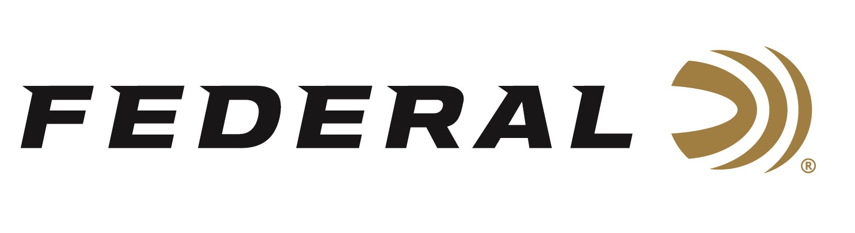

FOR IMMEDIATE RELEASE

Federal’s 7mm Backcountry Cartridge Named “Ammo of the Year” by Guns & Ammo

ANOKA, Minnesota – October 28, 2025 – Guns & Ammo magazine awarded Federal’s 7mm Backcountry cartridge as Ammo of the Year for 2025. The announcement was published in the December 2025 issue.
“We are extremely proud to have earned the prestigious designation of ‘Ammo of the Year’ from such an institutional publication and pillar in the industry, which Guns & Ammo certainly is,” said Federal’s Vice President of Product Development, Jesse Whiteside. “The 7mm Backcountry’s forward-thinking technology and design deserve the positive attention the article gave to it. We look forward to continued progression in what modern ammunition can do with the Peak Alloy case.”
“Federal’s patented Peak Alloy case technology enabled the cartridge’s achievement, which yields higher muzzle velocities from short-barreled rifles,” said Guns & Ammo Editor-in-Chief Eric R. Poole. “Short barrels on lighter rifles plus flatter trajectories equal greater success for hunters and long-range shooters.”

“Lightweight rifles with short barrels are easier to carry afield and are ideal for use with suppressors,” continued Poole. “Attaching a suppressor to a rifle chambered in 7mm Backcountry harnesses all the benefits of the cartridge with a familiar balance, handling, and weight. Using a suppressed rifle in 7mm Backcountry minimizes visible flash, reduces the audible report, thereby lowering stress on game and benefiting the shooter’s health.”

“Felt recoil is similar to rifles that chamber magnum rounds,” concluded Poole. “Even though observed pressures are higher, Guns & Ammo’s long-term testing supported Federal’s assertion that throat erosion and barrel life are comparable to those of similar cartridges.”

Federal’s 7mm Backcountry is a new high-performance hunting cartridge boosted by all-new, patented one-piece, high-strength Peak Alloy case technology, which provides magnum performance in a standard bolt face rifle. Through 20-inch barrels and with 170-grain bullets, it can achieve 3,000 feet per second. Federal has recently published reloading data on its brand website’s product information page.

Learn more at: Backcountry | Federal Premium

Federal Ammunition products are available at dealers nationwide and online. For more information on all Federal products and to sign up for notifications about new product availability, rebate promotions, and other brand news via email, visit www.federalpremium.com.

Press Release Contact: JJ Reich
Senior Manager – Press Relations
E-mail: media@tkghunt.com

About Federal Ammunition
Federal, headquartered in Anoka, MN, is an ammunition brand of The Kinetic Group, owned by CSG, a globally diversified industrial group based in Prague, Czech Republic. Since 1922, Federal has been a leader in ammunition innovation, delivering high-quality sporting and hunting products to shooters worldwide. With a commitment to conservation and the outdoor community, Federal continues to manufacture industry-leading ammunition that enhances the shooting experience while supporting outdoor traditions.

